School Name
Mathematics Test 2017
Year 10A |  | Non Linear Equations | Calculator Allowed
- Solve simple quadratic equations using a range of strategies (ACMNA241)  - 10 A Solve simple exponential equations (ACMNA270)  10A Factorise monic and nonmonic quadratic expressions and solve a wide range of quadratic equations derived from a variety of contexts (ACMNA269) |  |  | Name_________________
Section 1 Short Answer Section
Write all working and answers in the spaces provided on this test paper.

Solve the equation 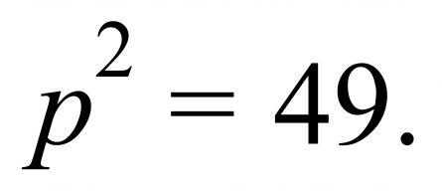

……………………………………………………………………………………………….

……………………………………………………………………………………………….
Find the values of x for which 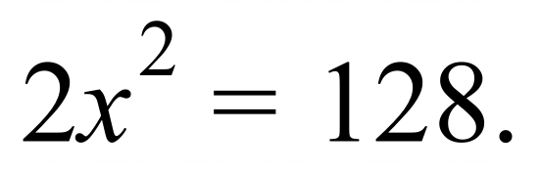

……………………………………………………………………………………………….

……………………………………………………………………………………………….
For what values of k is 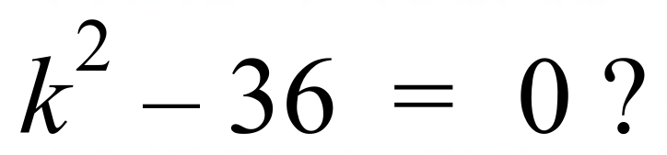

……………………………………………………………………………………………….

……………………………………………………………………………………………….
For what values of b is 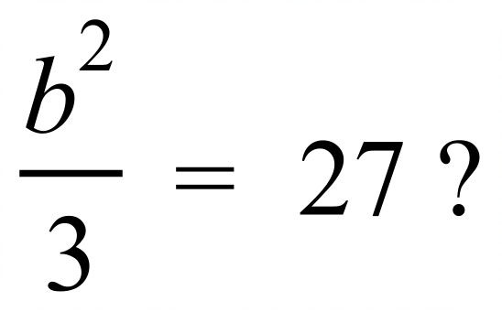

……………………………………………………………………………………………….

……………………………………………………………………………………………….
Solve for e: 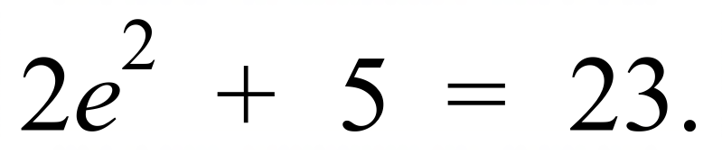

……………………………………………………………………………………………….

……………………………………………………………………………………………….
Write down the solutions to 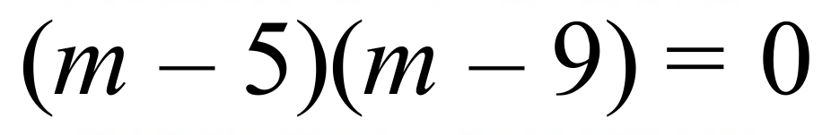.

……………………………………………………………………………………………....

……………………………………………………………………………………………….
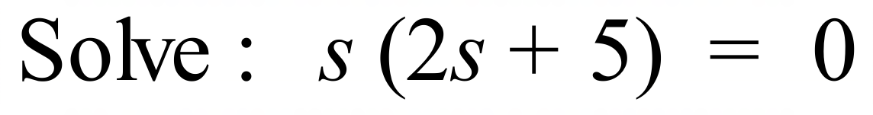

……………………………………………………………………………………………....

……………………………………………………………………………………………….
Solve the equation: 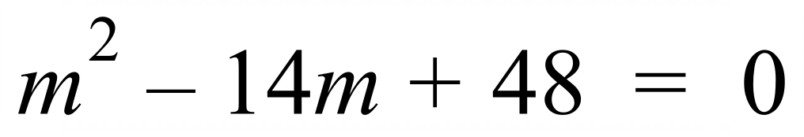.

……………………………………………………………………………………………....

……………………………………………………………………………………………….
Solve: 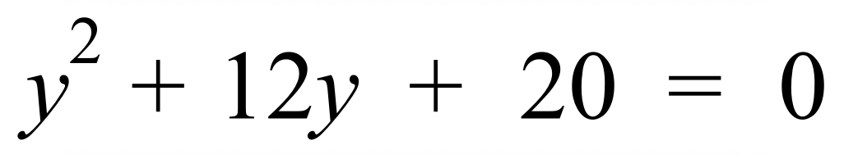.

……………………………………………………………………………………………....

……………………………………………………………………………………………….
Solve: 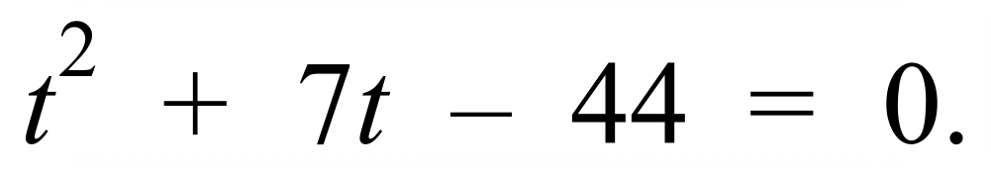

……………………………………………………………………………………………....

……………………………………………………………………………………………….
Solve: 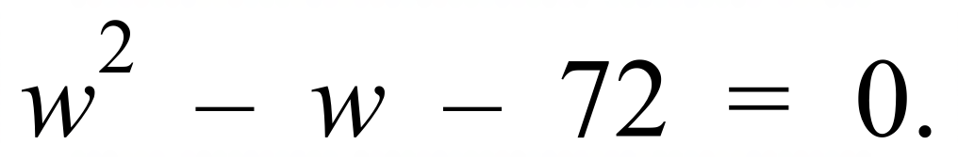

……………………………………………………………………………………………....

……………………………………………………………………………………………....

……………………………………………………………………………………………….
Solve 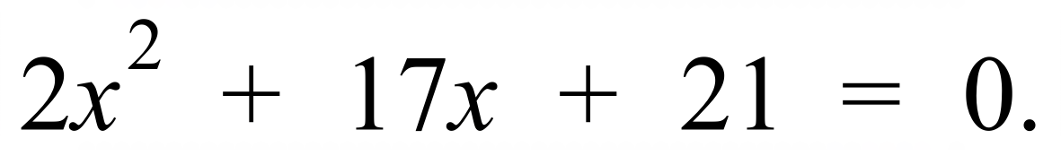

……………………………………………………………………………………………….

……………………………………………………………………………………………….

……………………………………………………………………………………………….
Solve 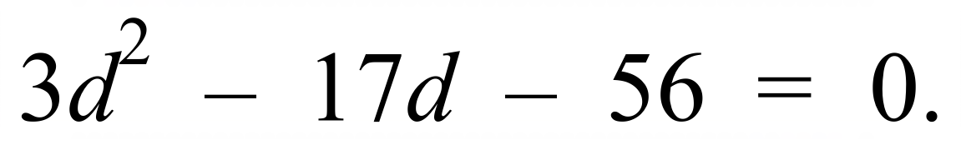

……………………………………………………………………………………………….

……………………………………………………………………………………………….

……………………………………………………………………………………………….

……………………………………………………………………………………………….

Give the exact values for which 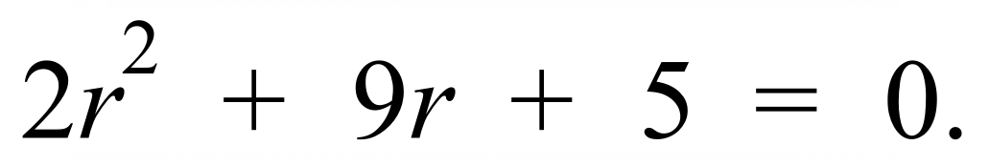

……………………………………………………………………………………………….

……………………………………………………………………………………………….

……………………………………………………………………………………………….

……………………………………………………………………………………………….
Complete the square on the equation 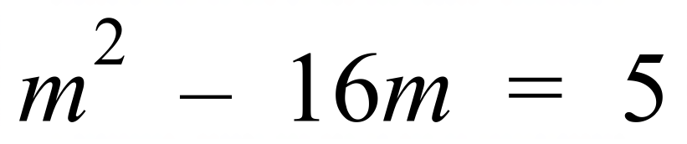, to find the solutions in surd form.

……………………………………………………………………………………………….

……………………………………………………………………………………………….

……………………………………………………………………………………………….

……………………………………………………………………………………………….

Find the solutions to 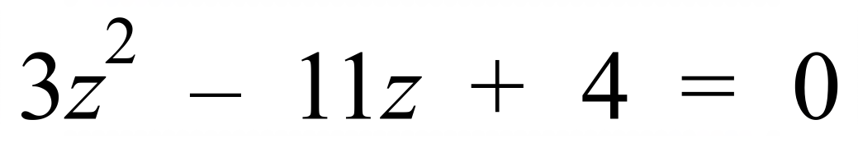, correct to two decimal places.

……………………………………………………………………………………………….

……………………………………………………………………………………………….

……………………………………………………………………………………………….

……………………………………………………………………………………………….

……………………………………………………………………………………………….

……………………………………………………………………………………………….
Determine how many solutions (if any) there are to the equation 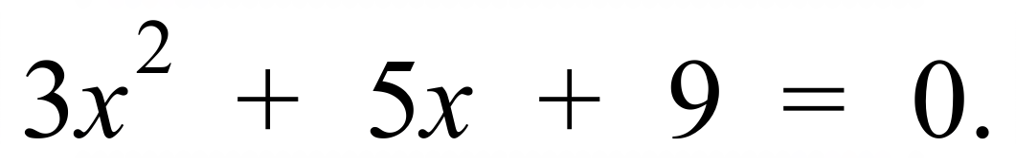
Give reasons for your answer.

……………………………………………………………………………………………….

……………………………………………………………………………………………….

……………………………………………………………………………………………….

……………………………………………………………………………………………….
Make w the subject of 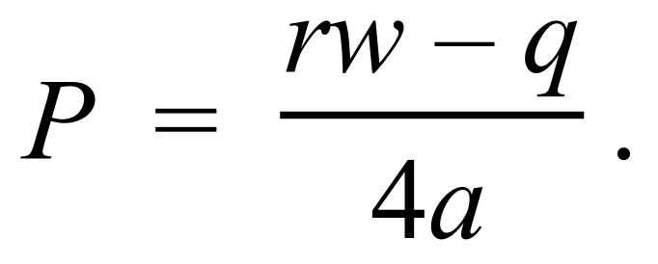

……………………………………………………………………………………………….

……………………………………………………………………………………………….

……………………………………………………………………………………………….

……………………………………………………………………………………………….

……………………………………………………………………………………………….

School Name
Mathematics Test 2017
Year 10A |  | Non Linear Equations | Calculator Allowed
 |  | Non Linear Equations | Name_________________
Section 2 Multiple Choice Section
Mark all your answers on the accompanying multiple choice answer sheet, not on this test paper. You may do any working out on this test paper. Calculators are allowed for this section.

The solutions to 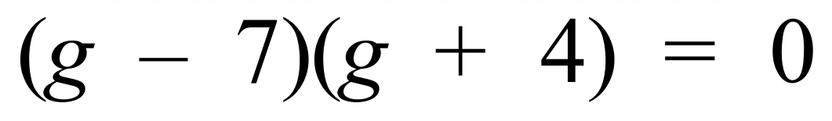 are:

A. 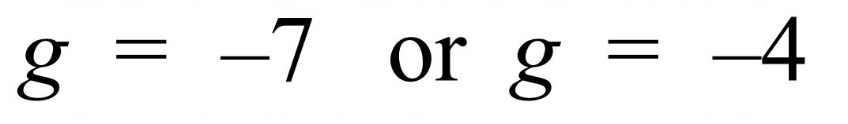 B. 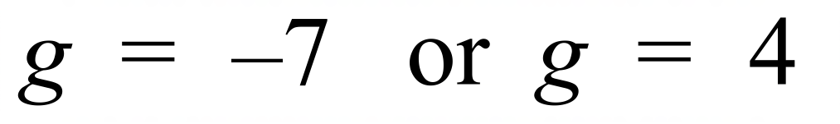
C. 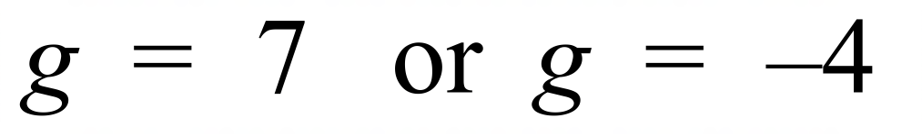 D. 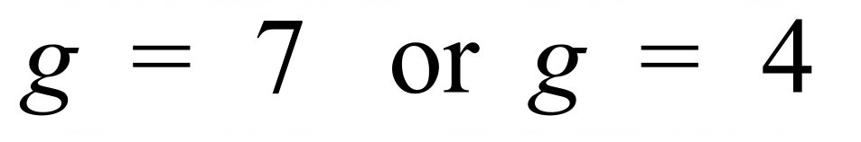
Solve 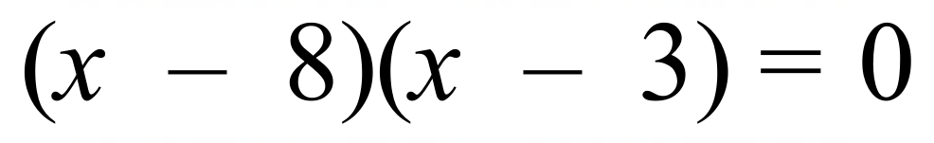.

A. 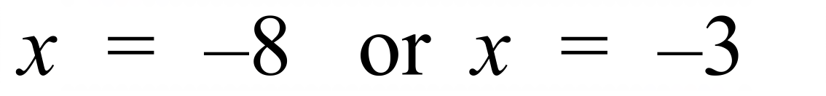 B. 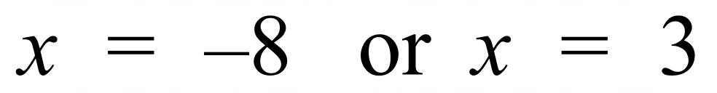
C. 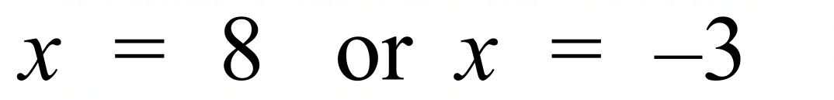 D. 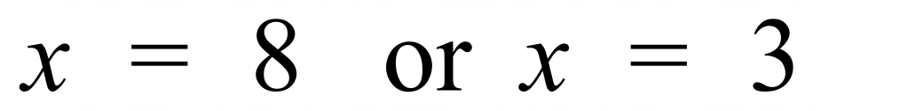
For what values of x is 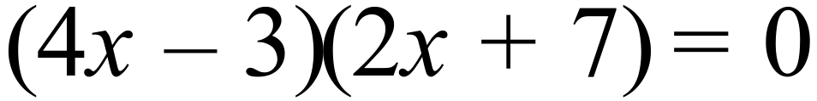?

A. 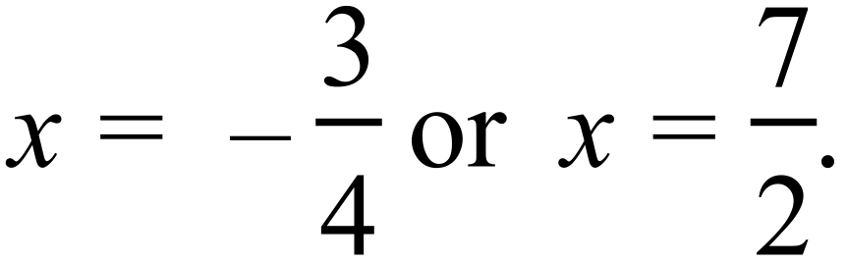 B. 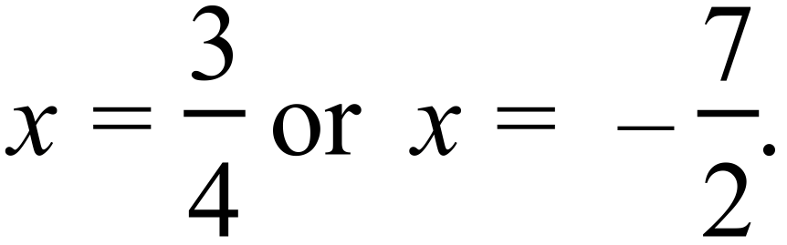
C. 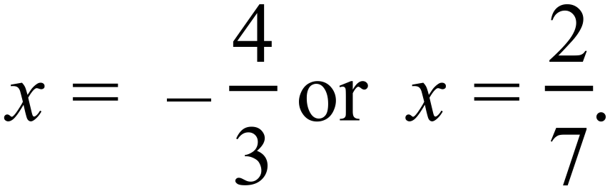 D. 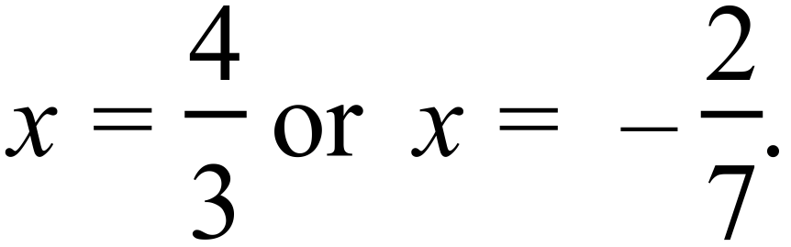
The solutions to 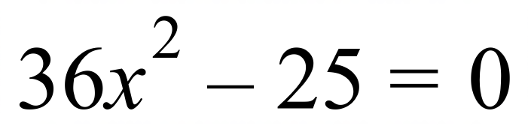 are:

A. 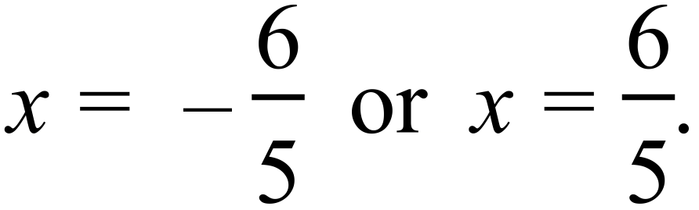 B. 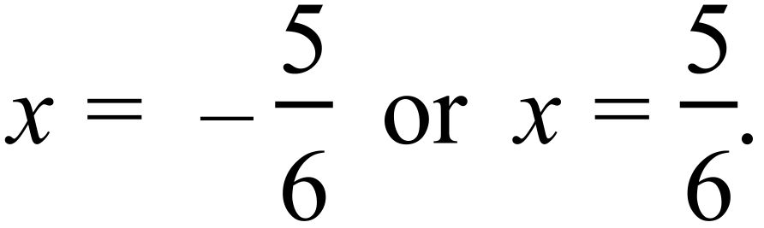
C. 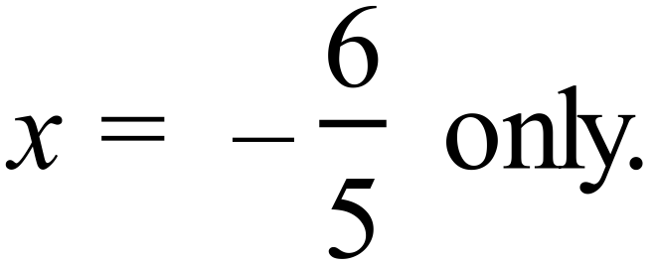 D. 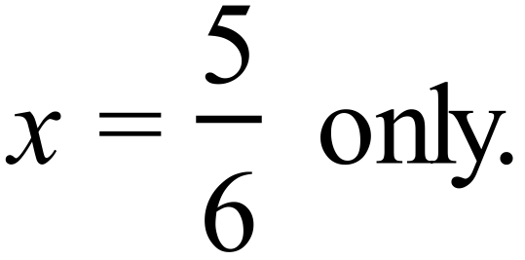
What are the solutions to 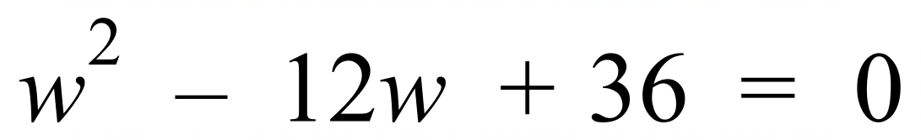?

A. 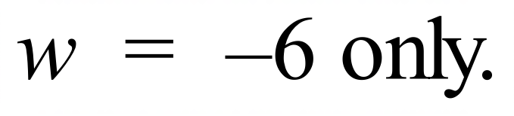 B. 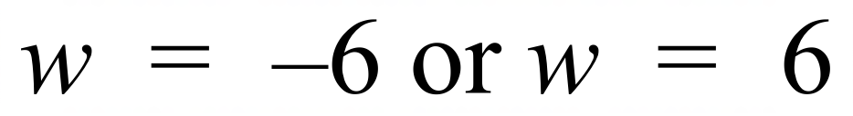
C. 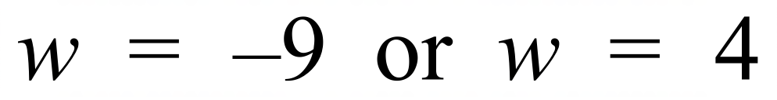 D. 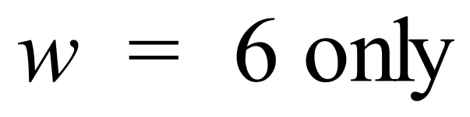
The solutions to 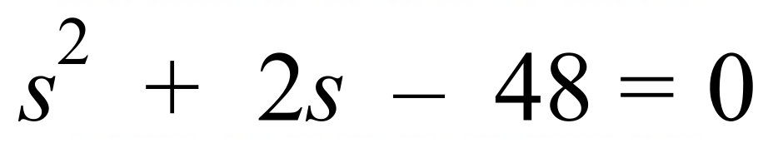 are:

A. 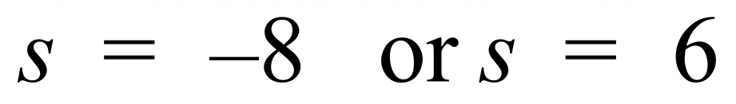 B. 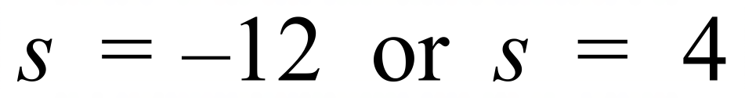
C. 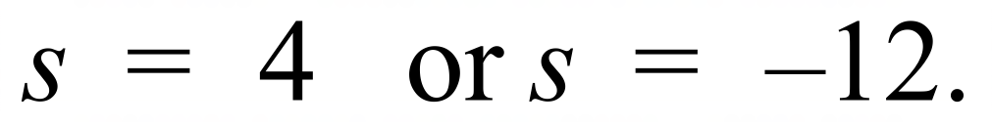 D. 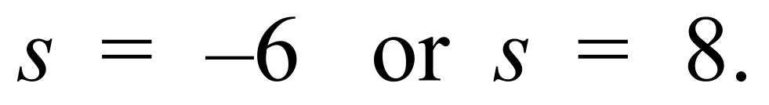
Solve 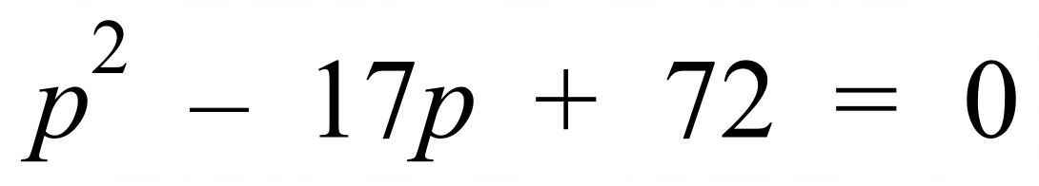.

A. 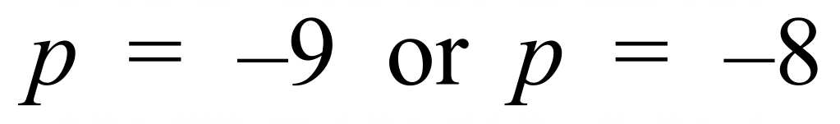 B. 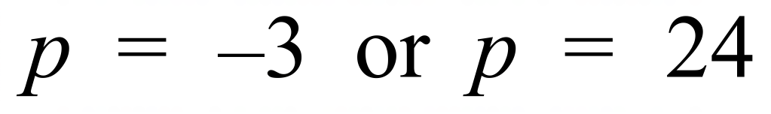
C. 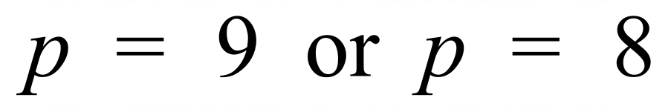 D. 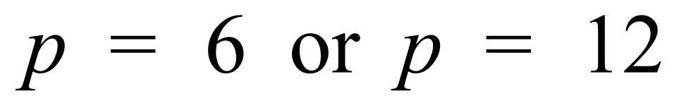
Solve 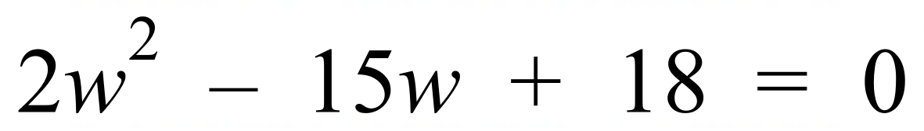

A. 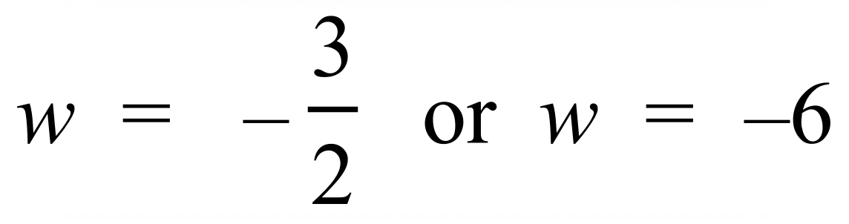 B. 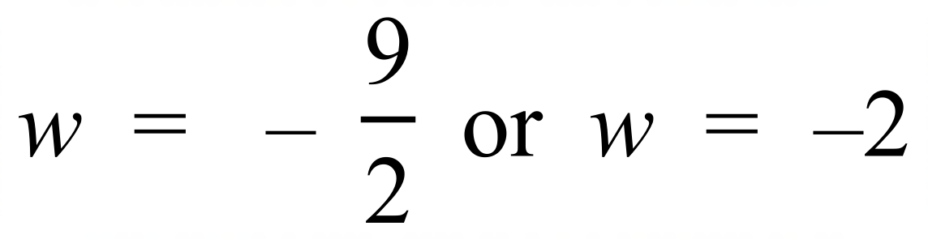
C. 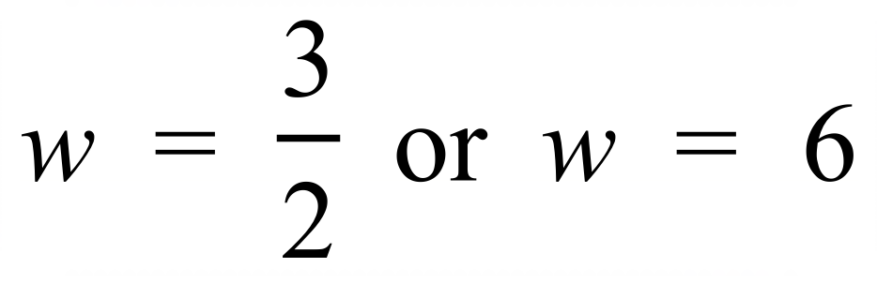 D. 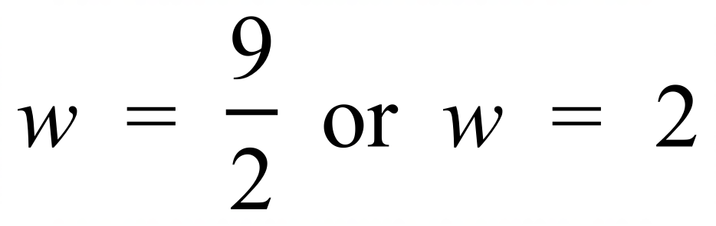
Solve 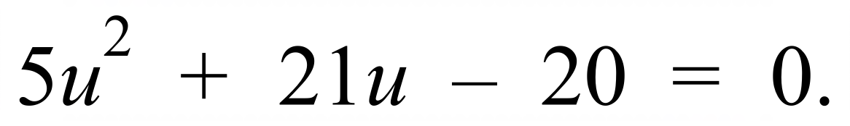

A. 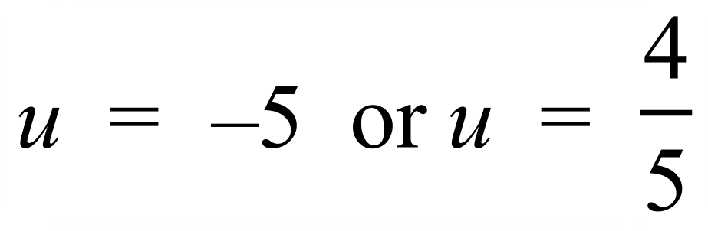 B. 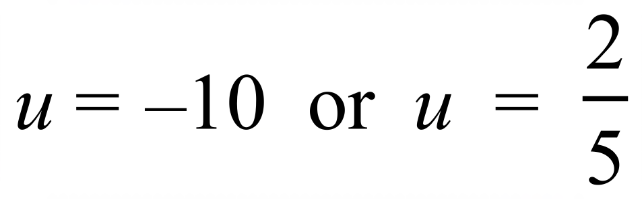
C. 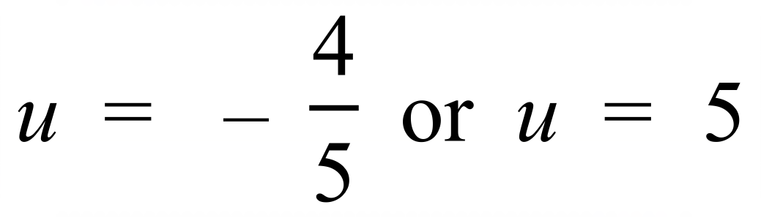 D. 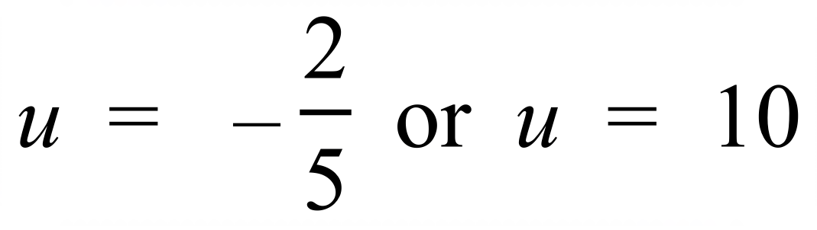
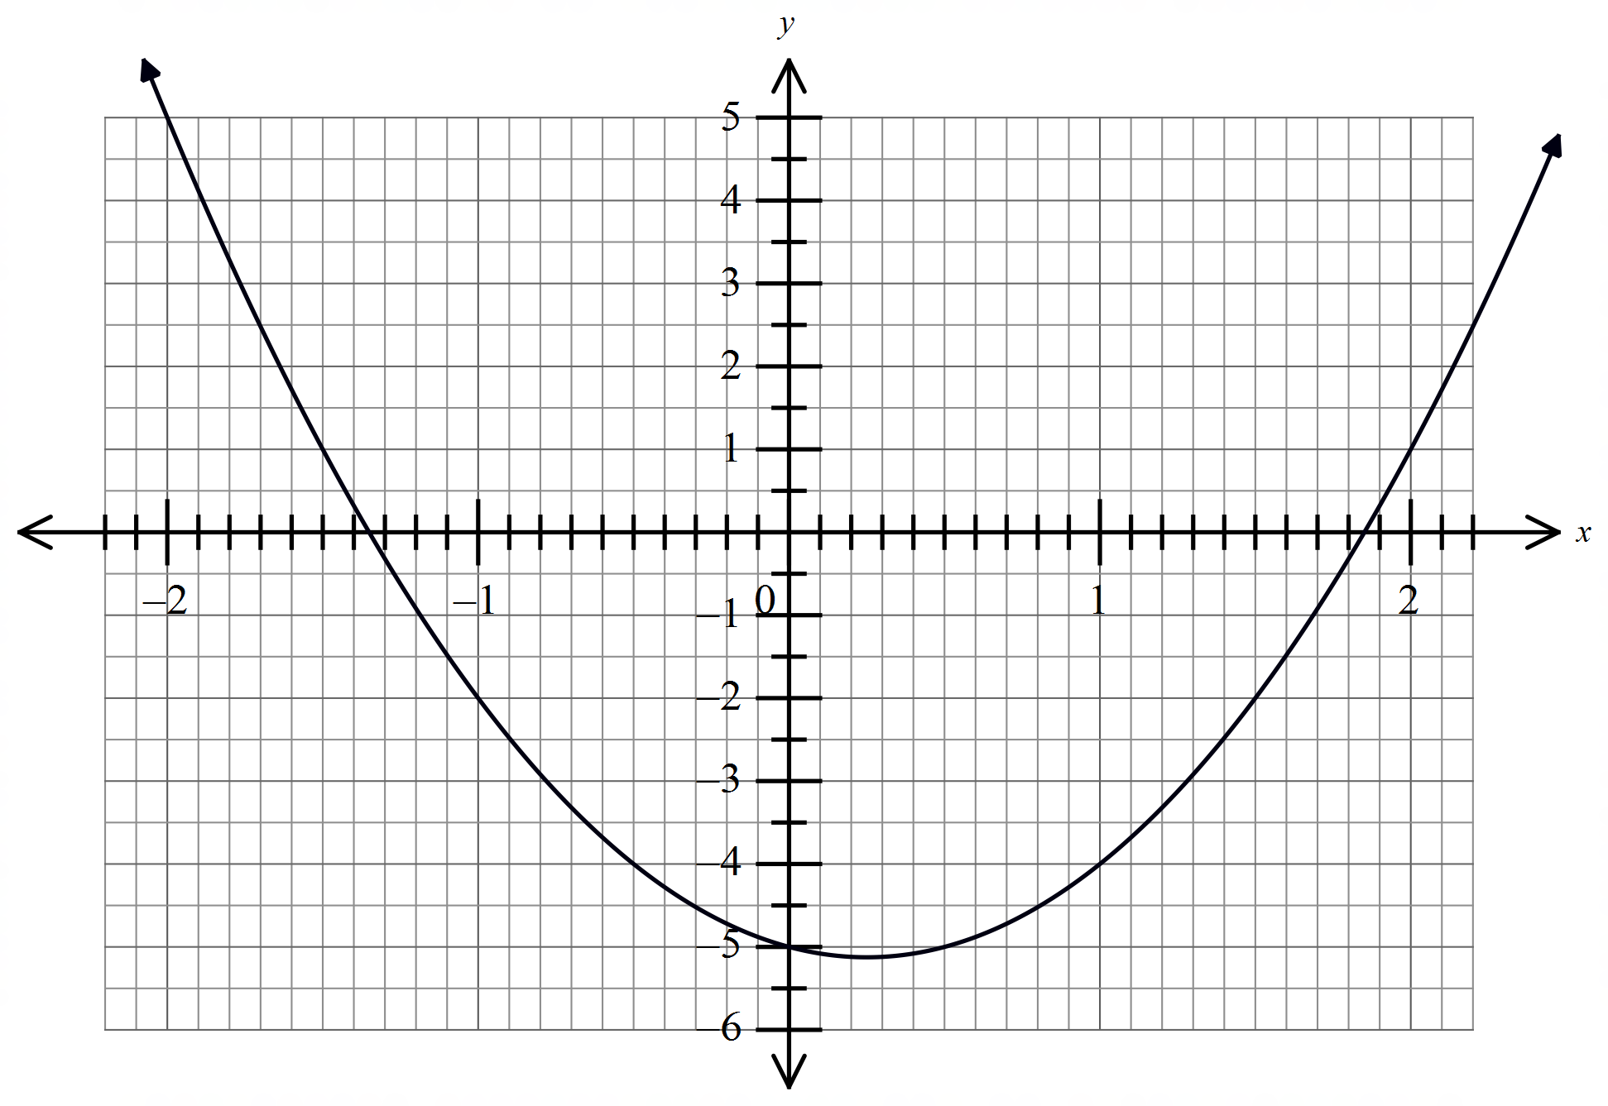The graph of 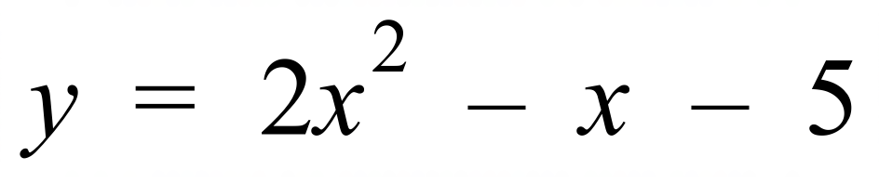 is shown.
Estimate the solution to
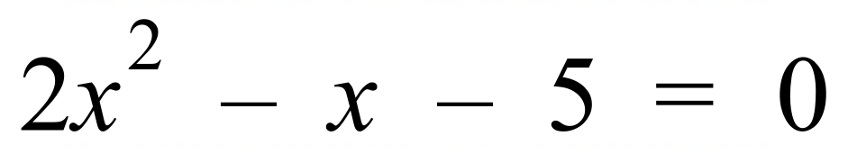

A. 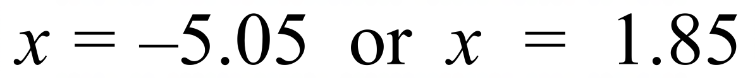
B. 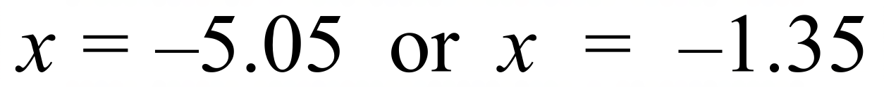
C. 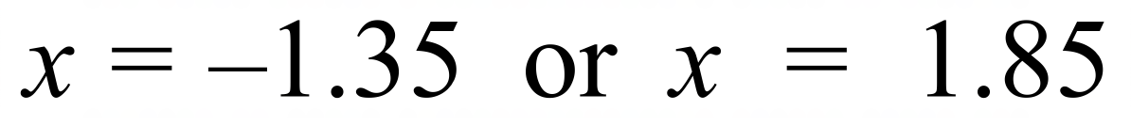
D. 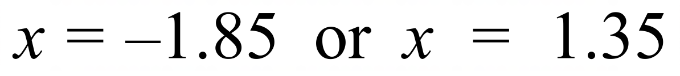

Find all the solutions to 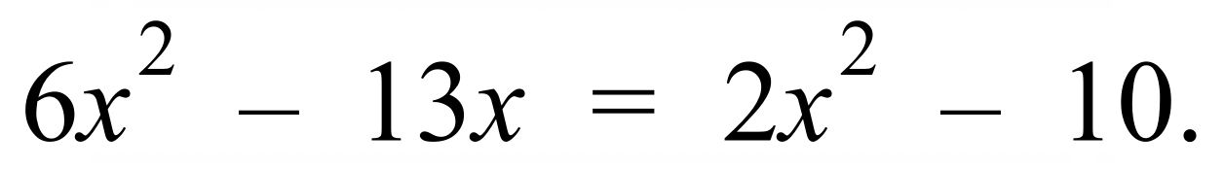

A. 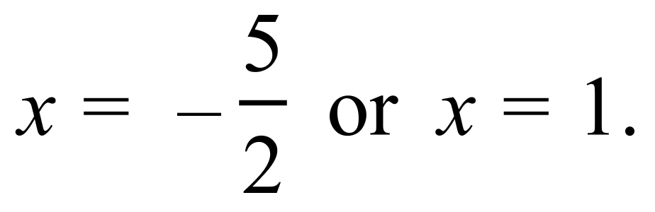 B. 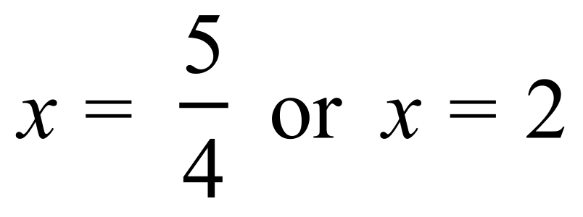
C. 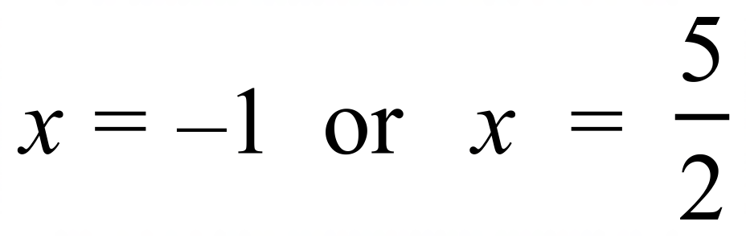 D. 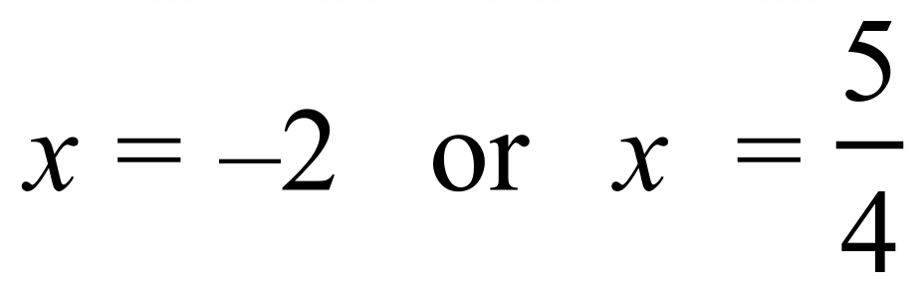
The solutions to 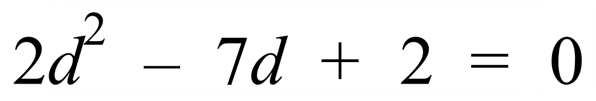 are:

A. 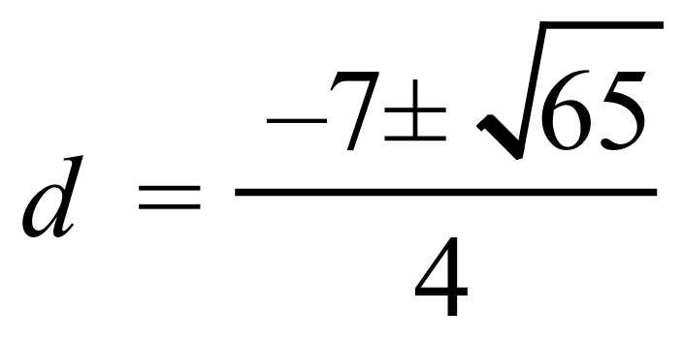 B. 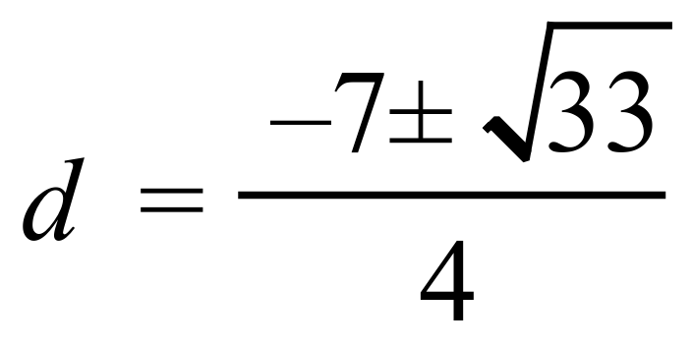
C. 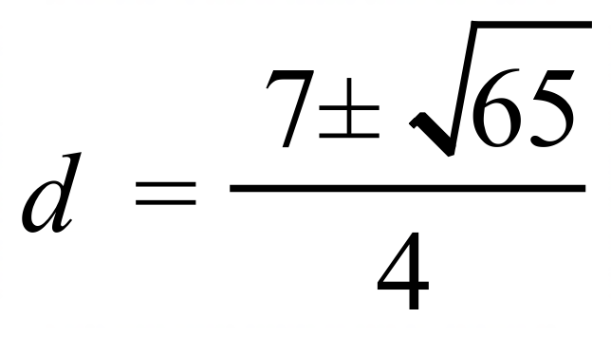 D. 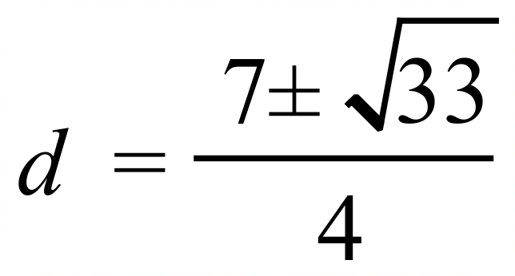
To solve 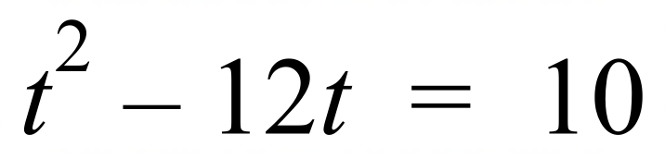, Josh completes the square on the left-hand side of the equation.
What value must he add to both sides of the equation to achieve this?

A. 12 B. 36 C. 120 D. 144
What is the solution to 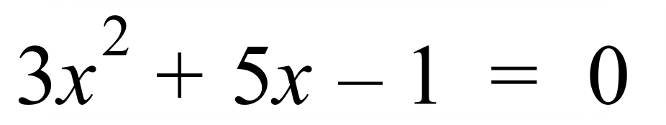 , correct to one decimal place?

A. 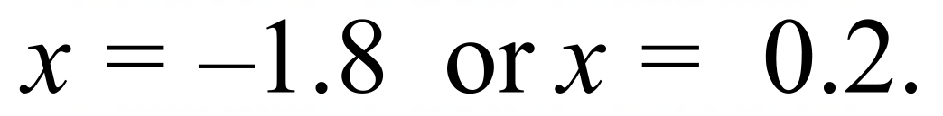 B. 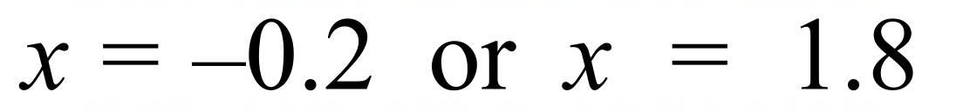
C. 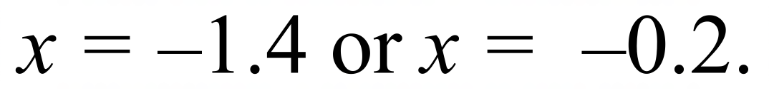 D. 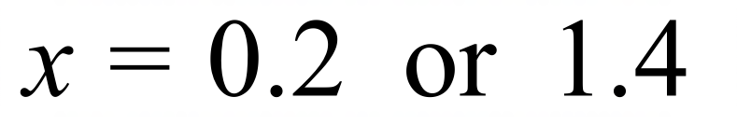
For what value of s is 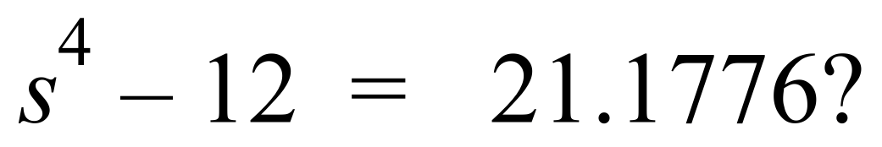

A. 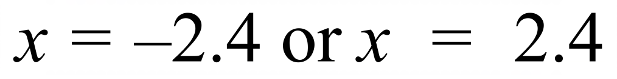 B. 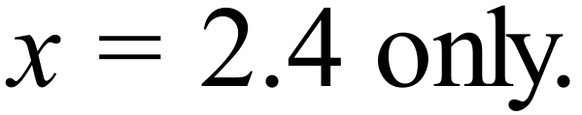
C. 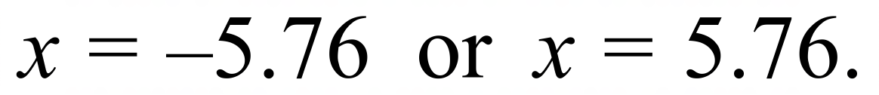 D. 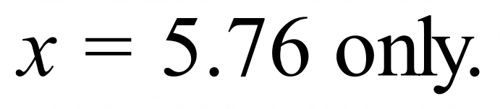
 | A. 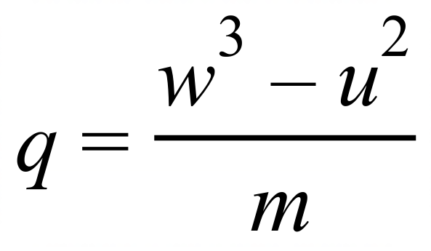 B. 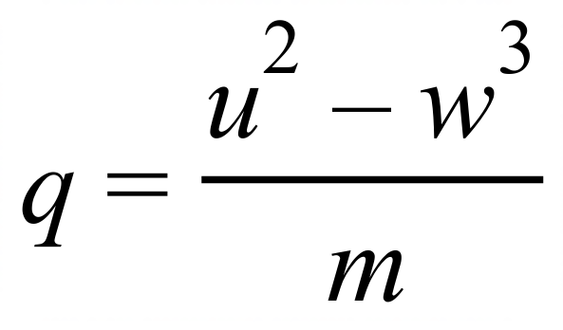 C. 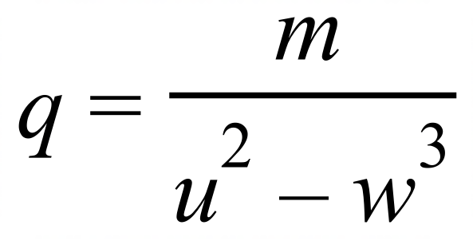 D. 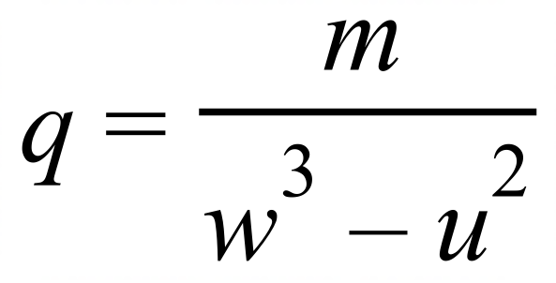

School Name
Mathematics Test 2017
Year 10A | Non Linear Equations | Calculator Allowed
Year 10A | Non Linear Equations | Name___________________
Section 3 Longer Answer Section
Write all working and answers in the spaces provided on this test paper.

 |  | Marks
1. | (a) Solve 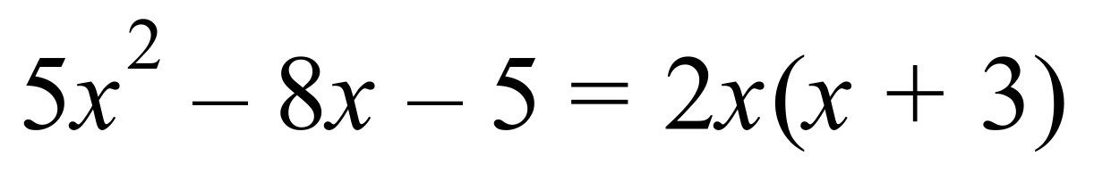  ……………………………………………………………………………………………….  ……………………………………………………………………………………………….  ……………………………………………………………………………………………….  ……………………………………………………………………………………………….  ……………………………………………………………………………………………… | 3
 | (b) Solve 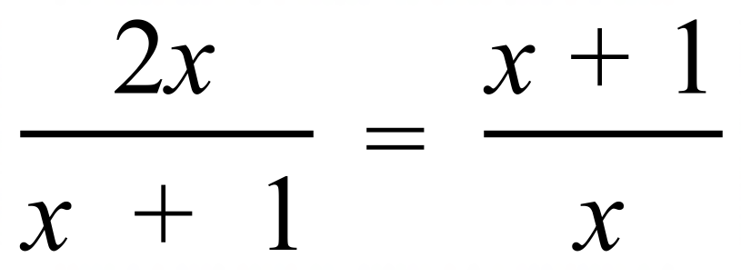 .  ……………………………………………………………………………………………….  ……………………………………………………………………………………………….  ……………………………………………………………………………………………….  ……………………………………………………………………………………………….  ……………………………………………………………………………………………… | 3
 | (c) Two positive numbers differ by 12.5 and have a product of 456.  - If the smaller number is n, write an expression for the larger number.  ……………………………………………………………………………………………….  - Write an equation for the product of the two numbers.  ……………………………………………………………………………………………….  - Solve the equation to find the value of the two numbers.  ……………………………………………………………………………………………….  ……………………………………………………………………………………………….  ……………………………………………………………………………………………….  ……………………………………………………………………………………………….  ………………………………………………………………………………………………  ………………………………………………………………………………………………. | 1  1  3
2. | Find the x values of the points which simultaneously solve these equations.  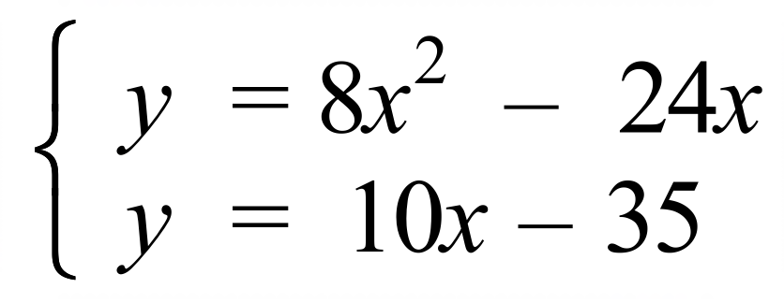  ……………………………………………………………………………………………….  ……………………………………………………………………………………………….  ……………………………………………………………………………………………….  ……………………………………………………………………………………………….  ………………………………………………………………………………………………  ………………………………………………………………………………………………. | 3

School Name
Mathematics 2017
Multiple Choice Answer Sheet
Non Linear Equations
Name _____________________________________________
Completely fill the response oval representing the most correct answer.
1. A B C D
2. A B C D
3. A B C D
4. A B C D
5. A B C D
6. A B C D
7. A B C D
8. A B C D
9. A B C D
10. A B C D
11. A B C D
12. A B C D
13. A B C D
14. A B C D
15. A B C D
16. A B C D

School Name
Mathematics Test 2017
Year 10A | Non Linear Equations | Non Calculator Section
ANSWERS

Question | Working and Answer
 | 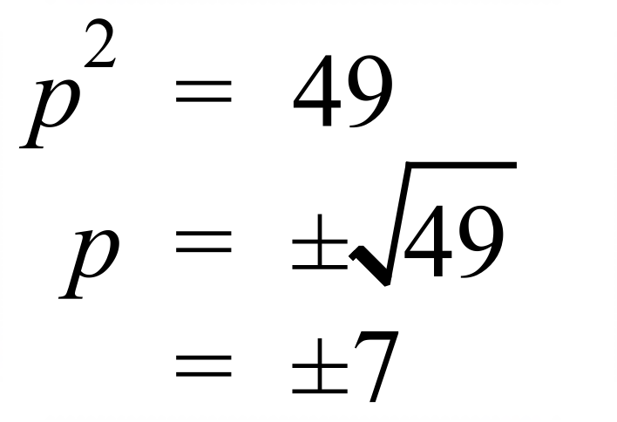
 | 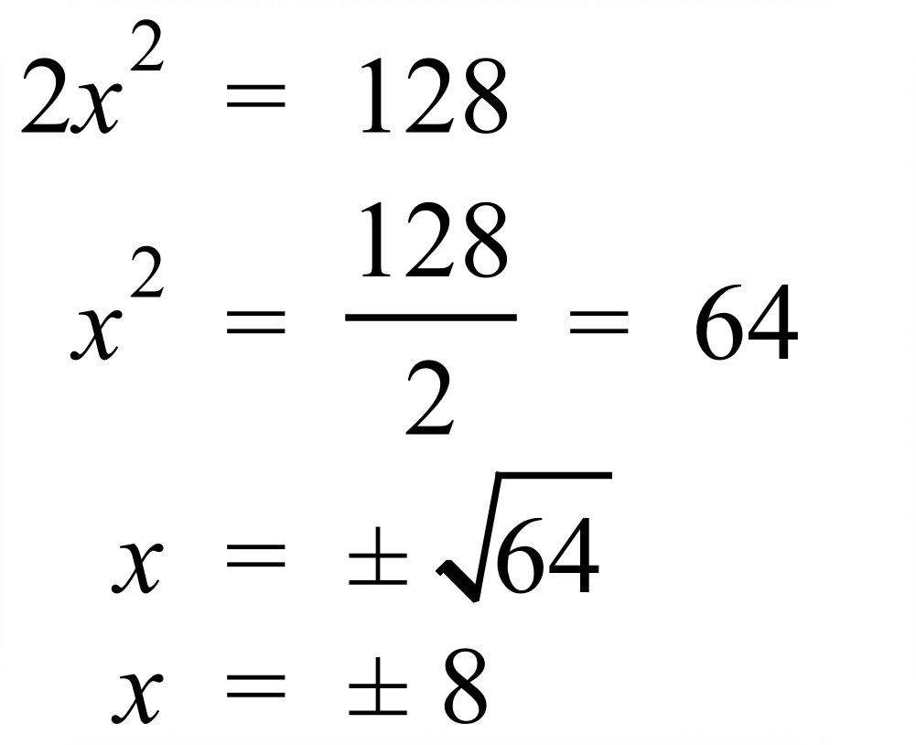
 | 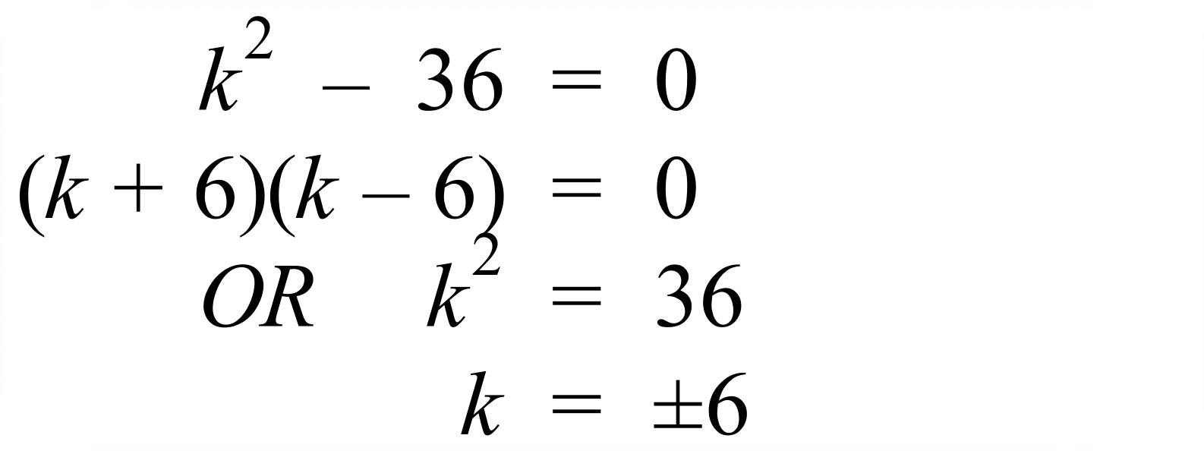
 | 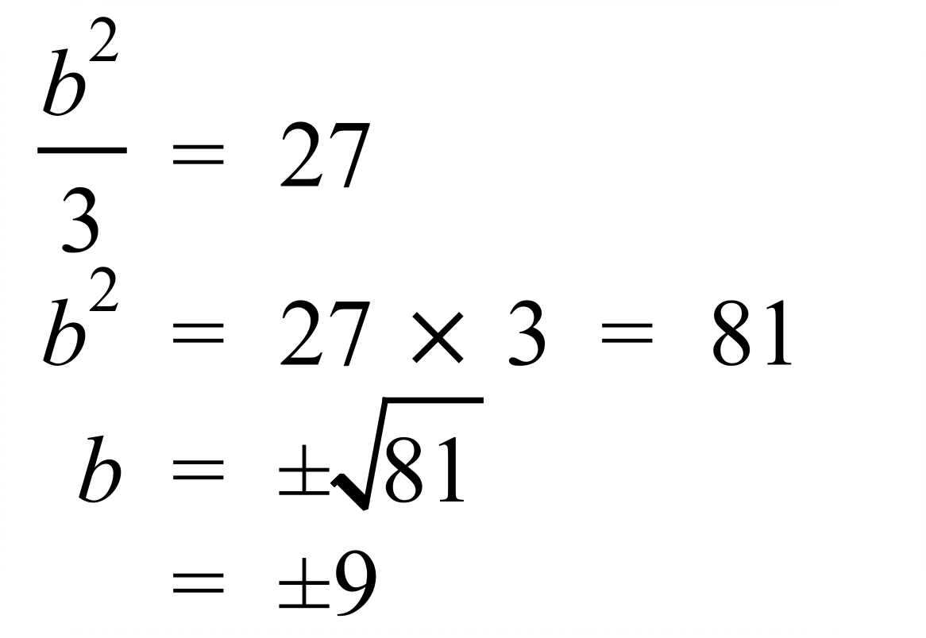
 | 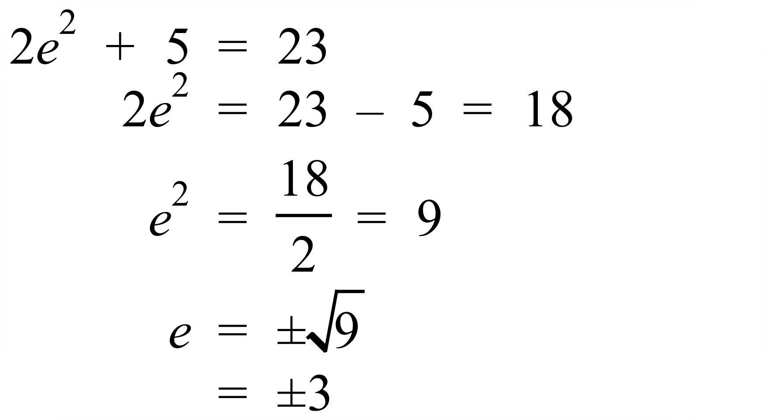
 | 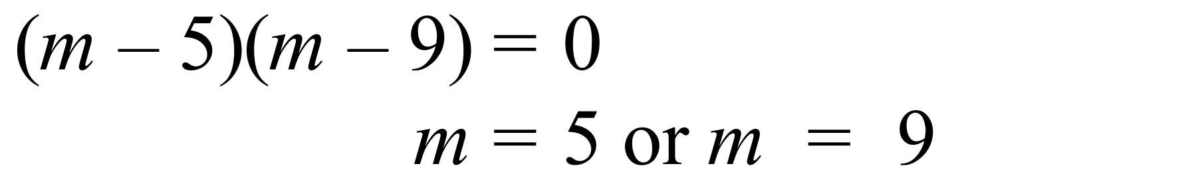
 | 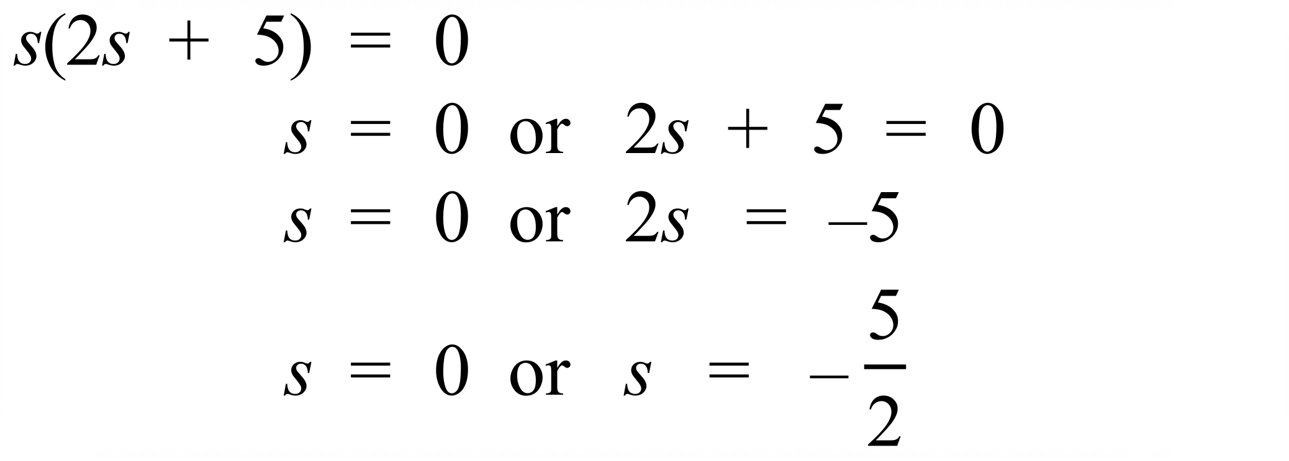
 | 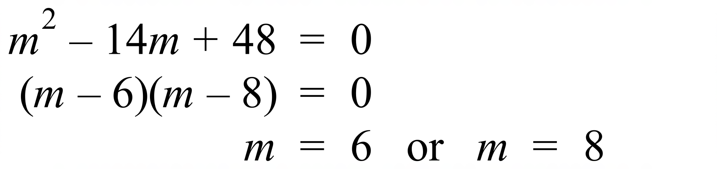.
 | 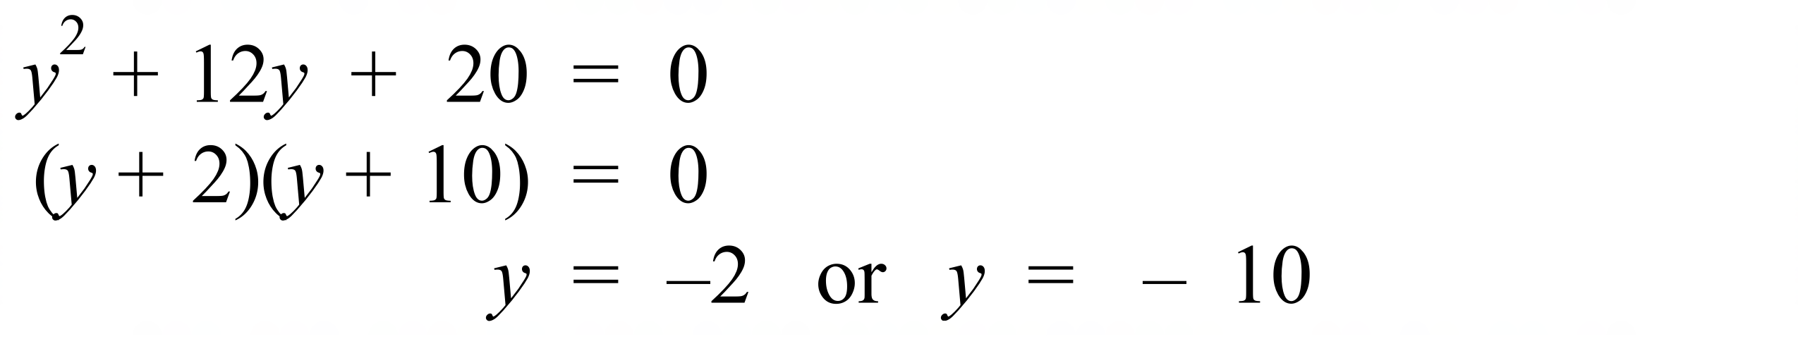
 | 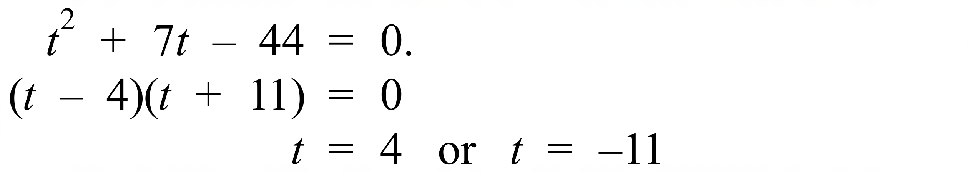
 | 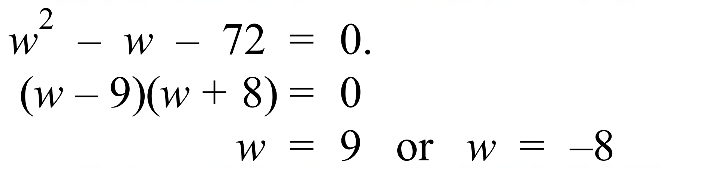
 | 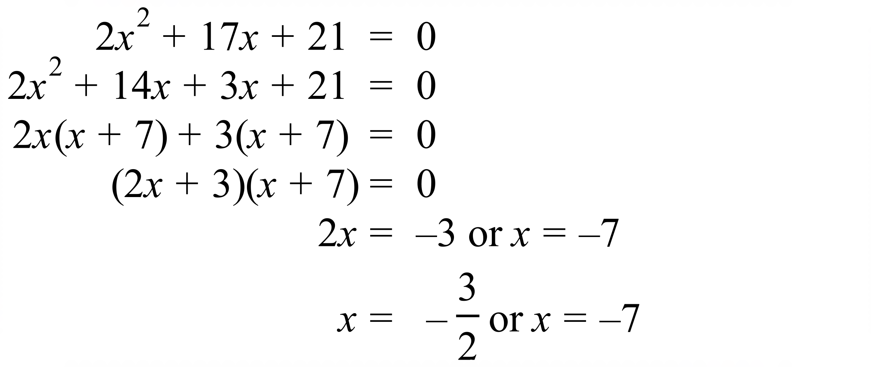 *
 | 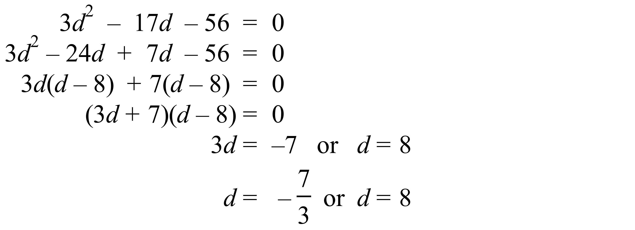
 | 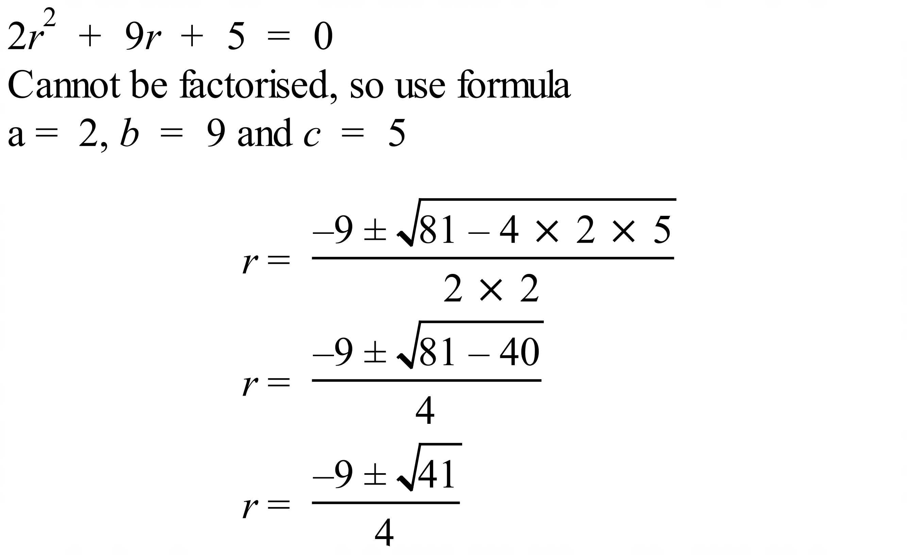
 | 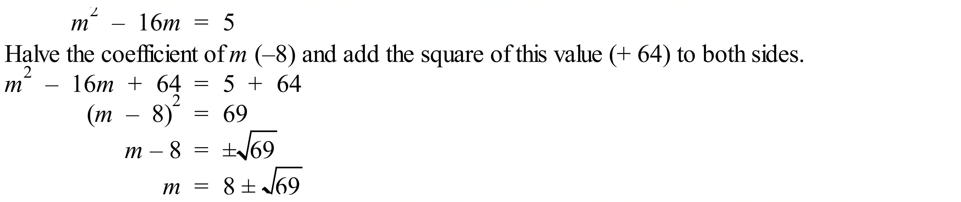
 | 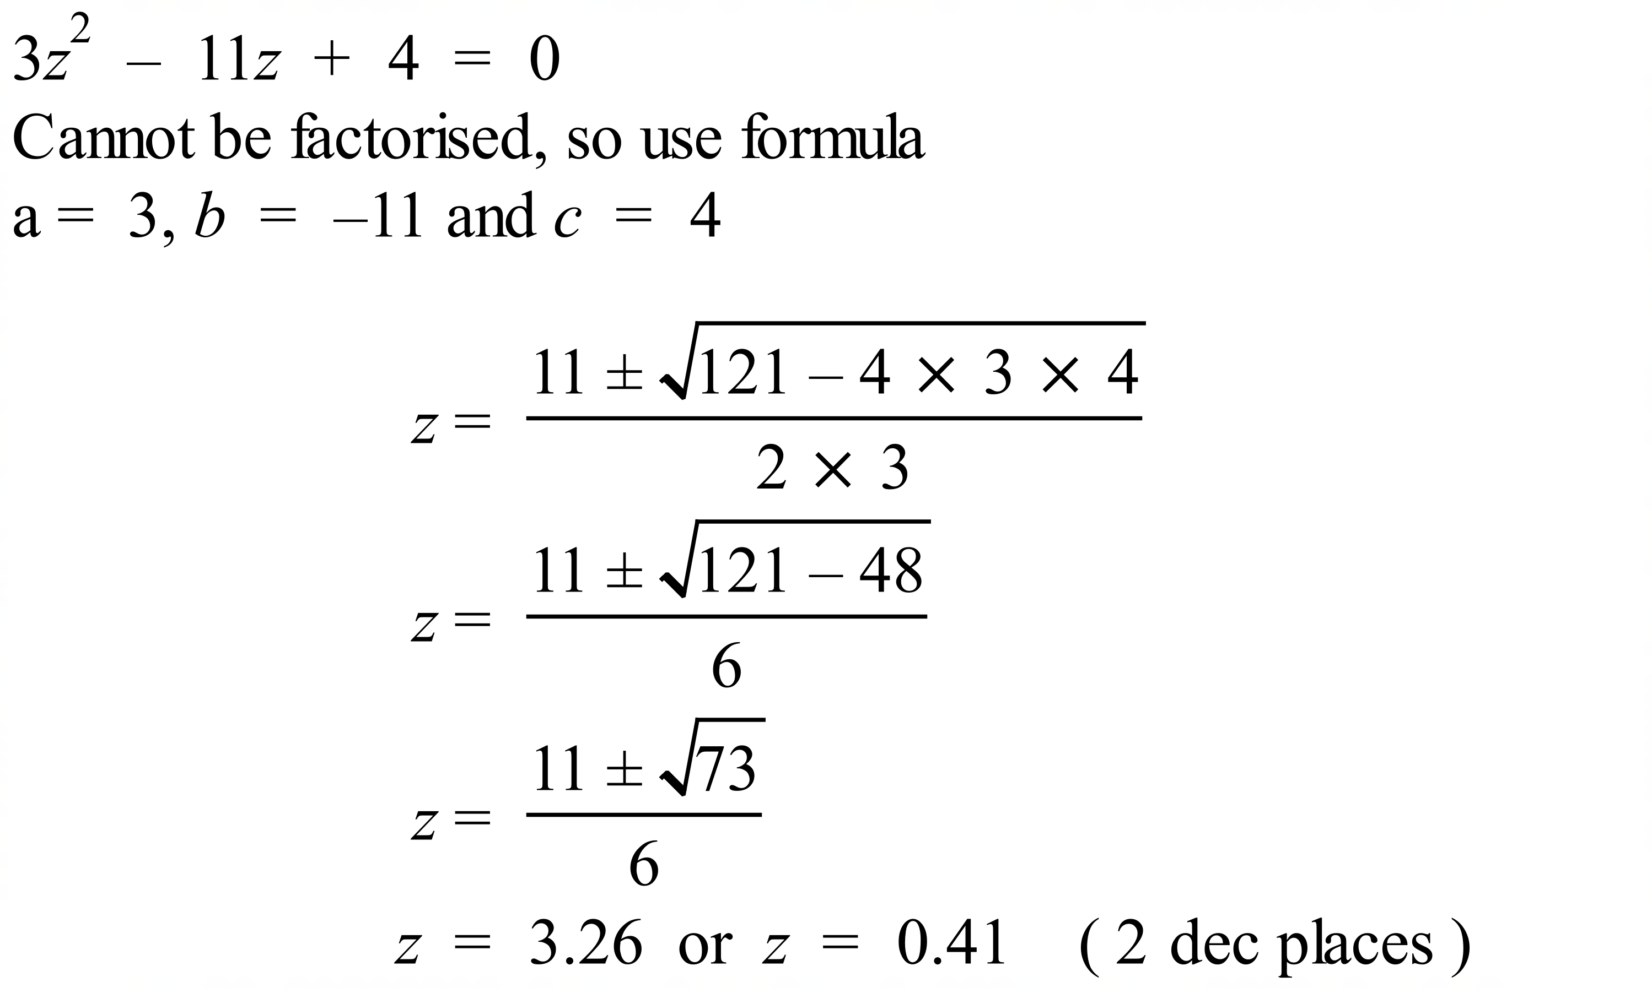
 | 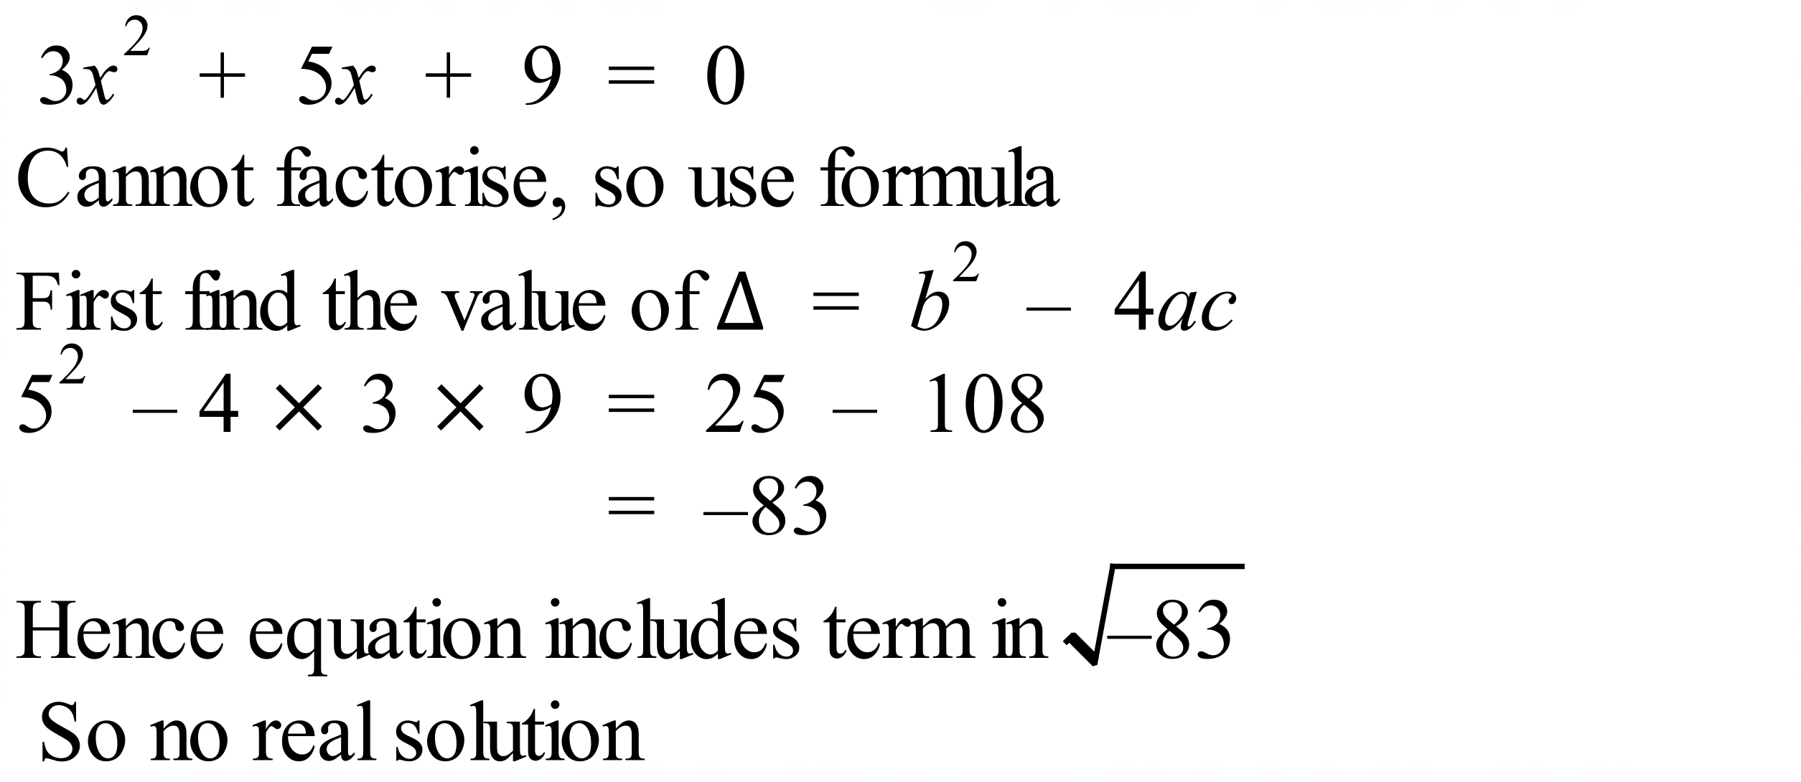
 | 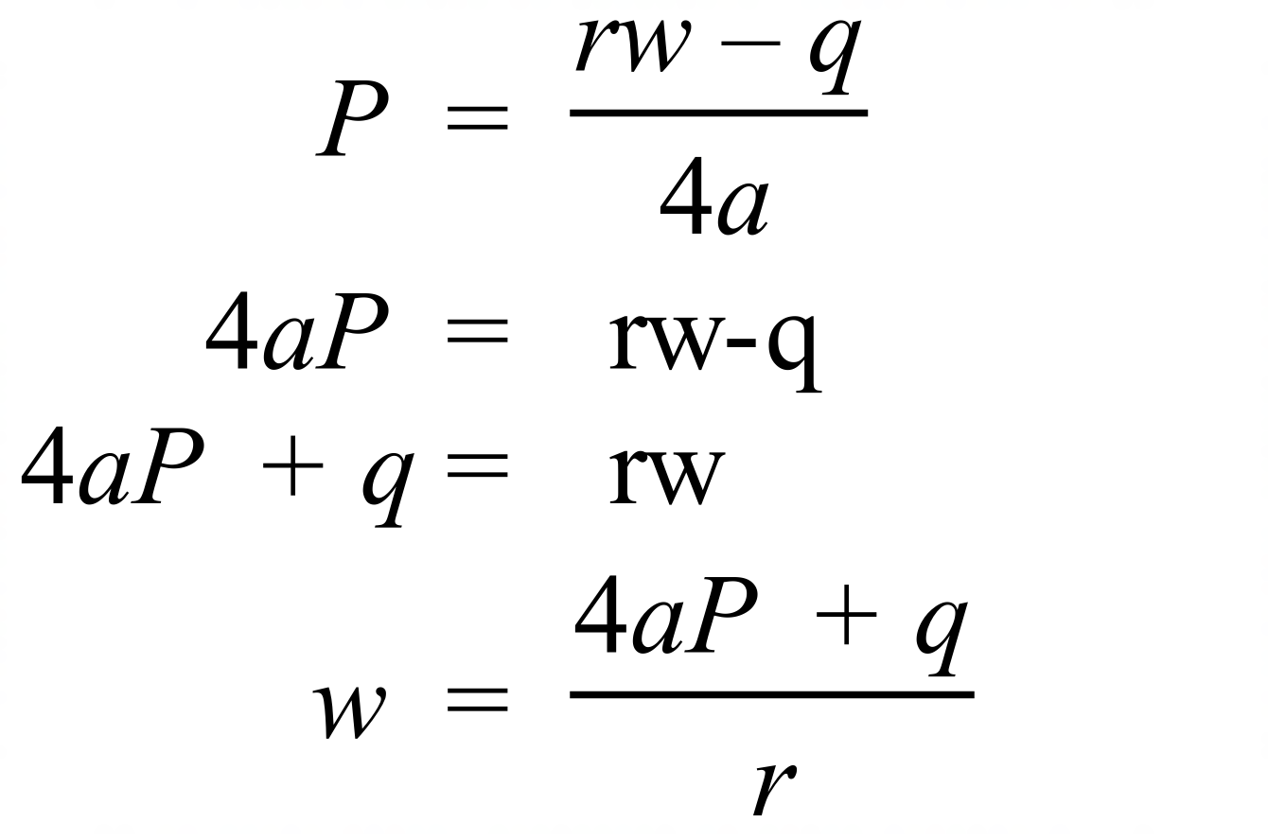

School Name
Mathematics Test 2017
Year 10A | Non Linear Equations | Calculator Allowed  Multiple Choice  Section

ANSWERS

Question | Working | M C Answer
 | 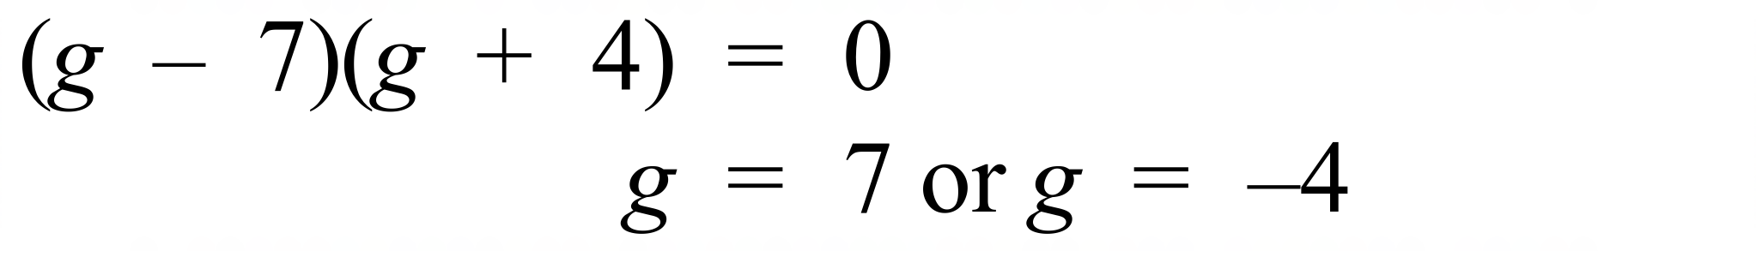 | C
 | 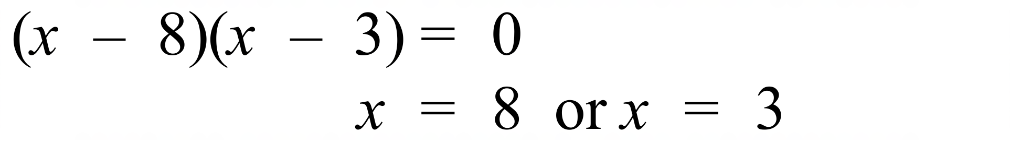 | D
 | 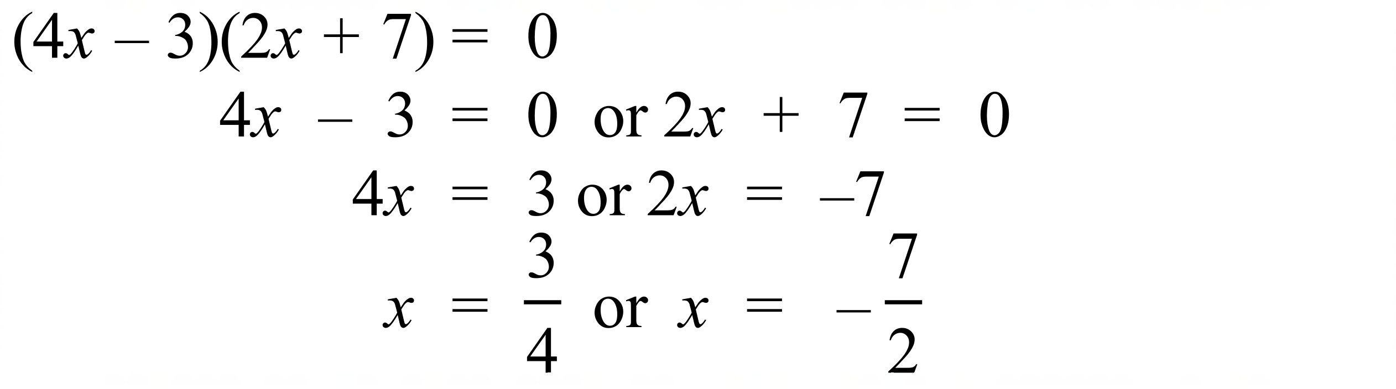 | B
 | 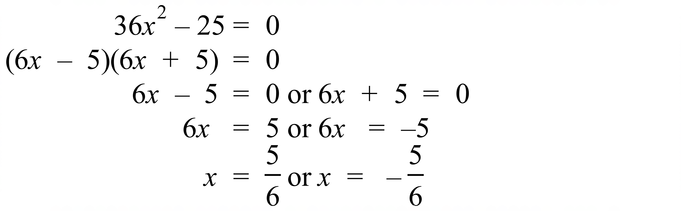 | B
 | 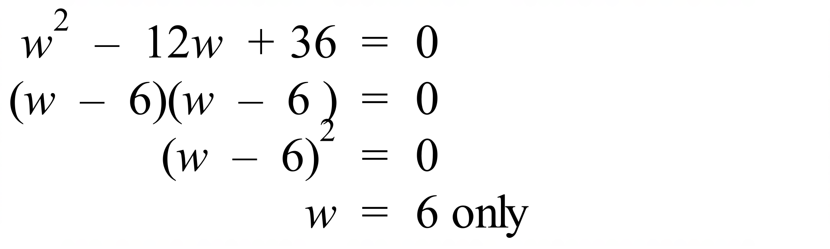 | D
 | 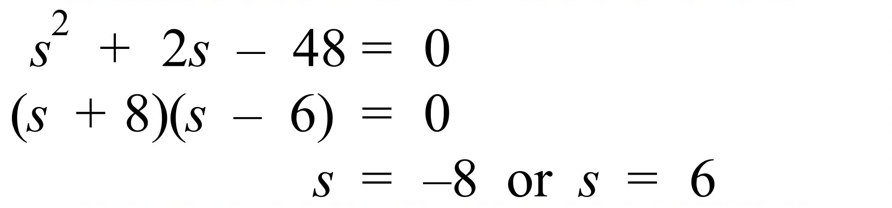 | A
 | 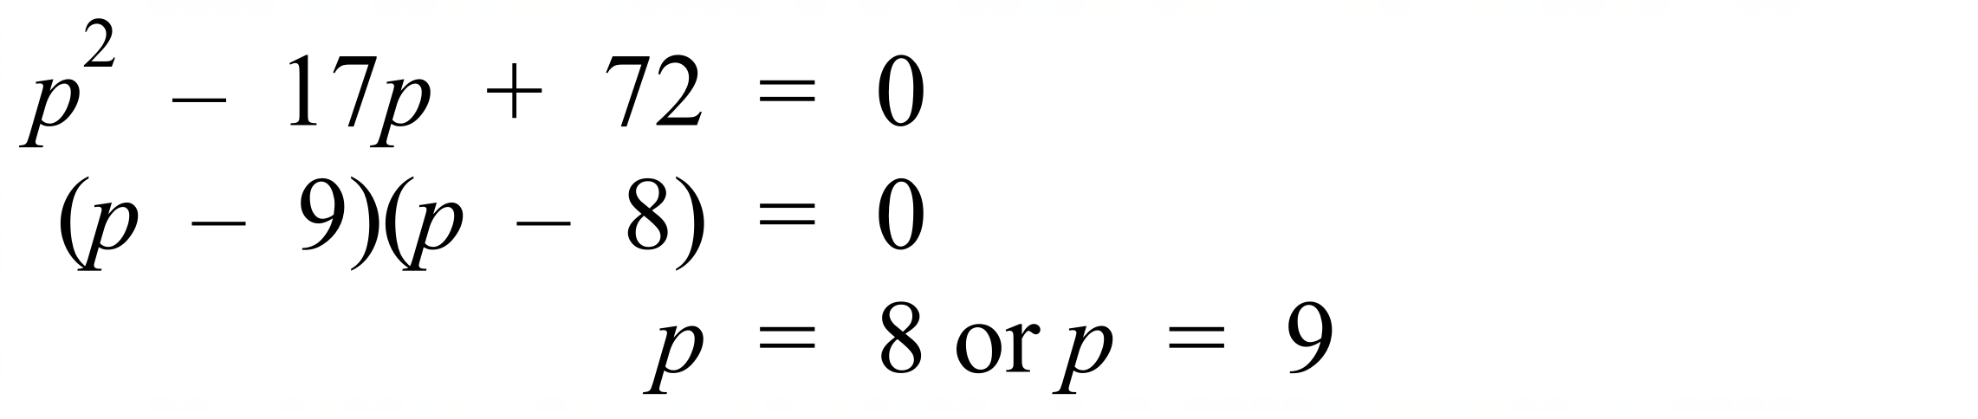 | C
 | 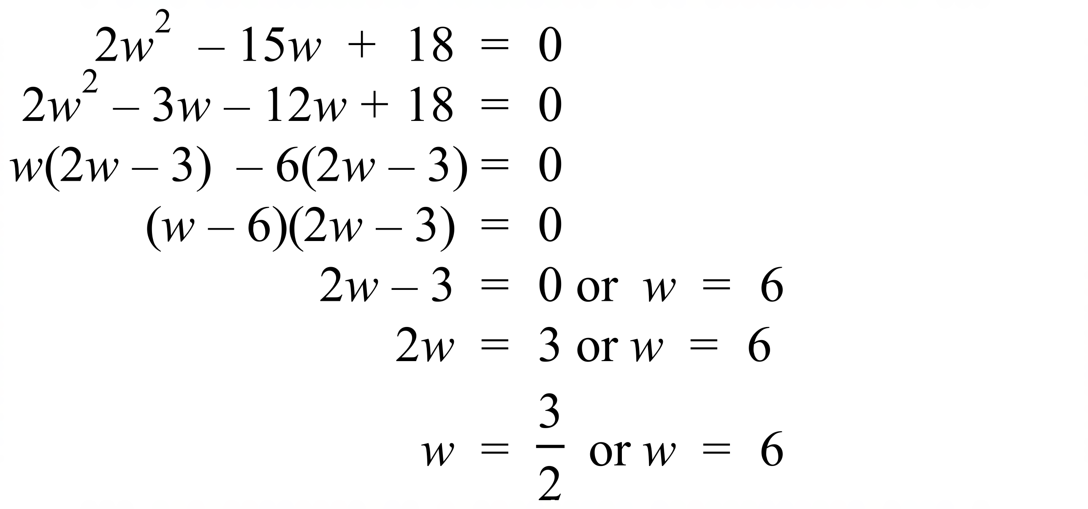 | C
 | 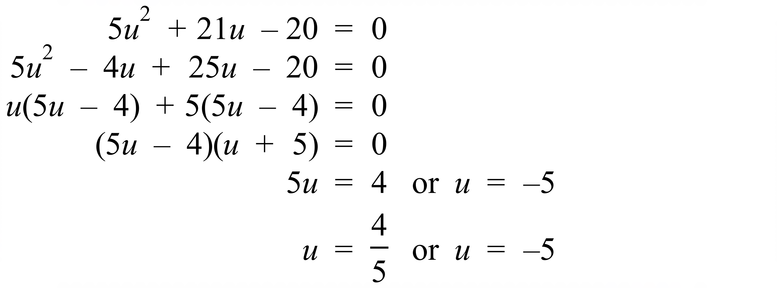 | A
 | 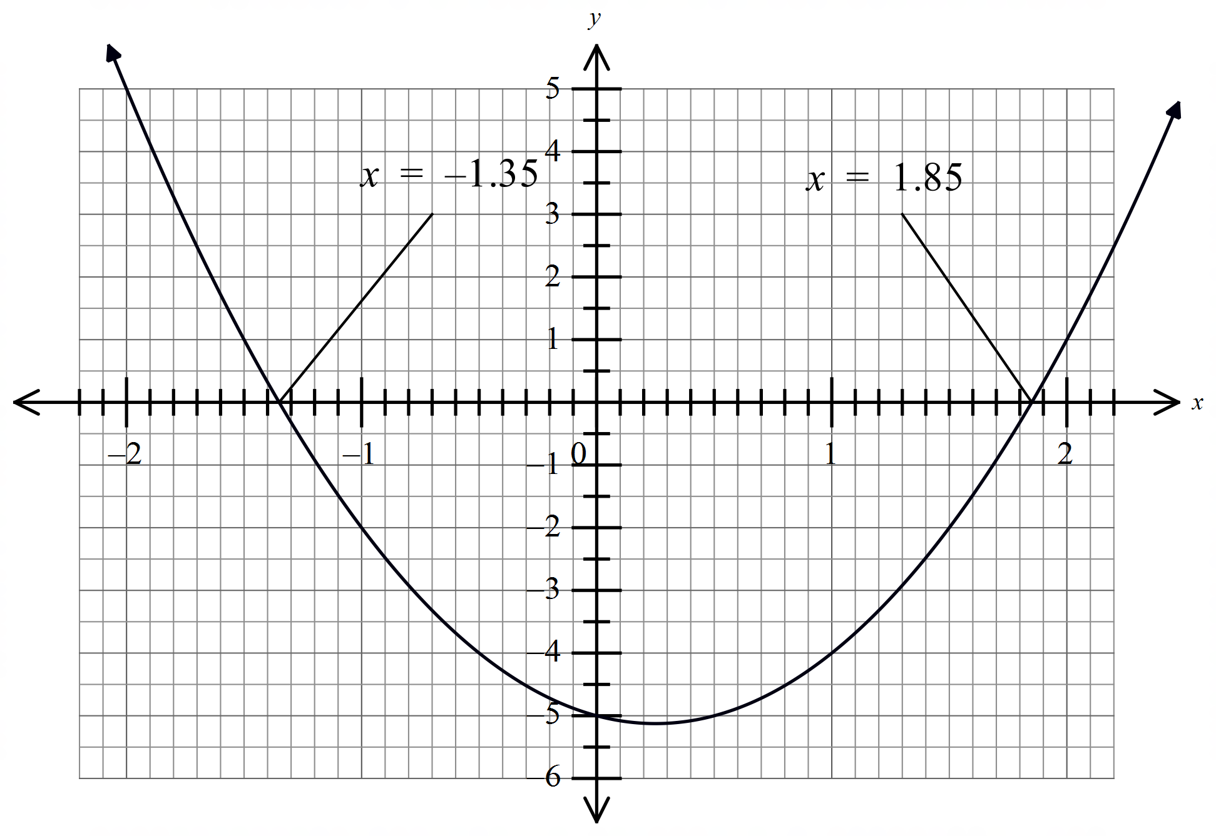 | C
 | 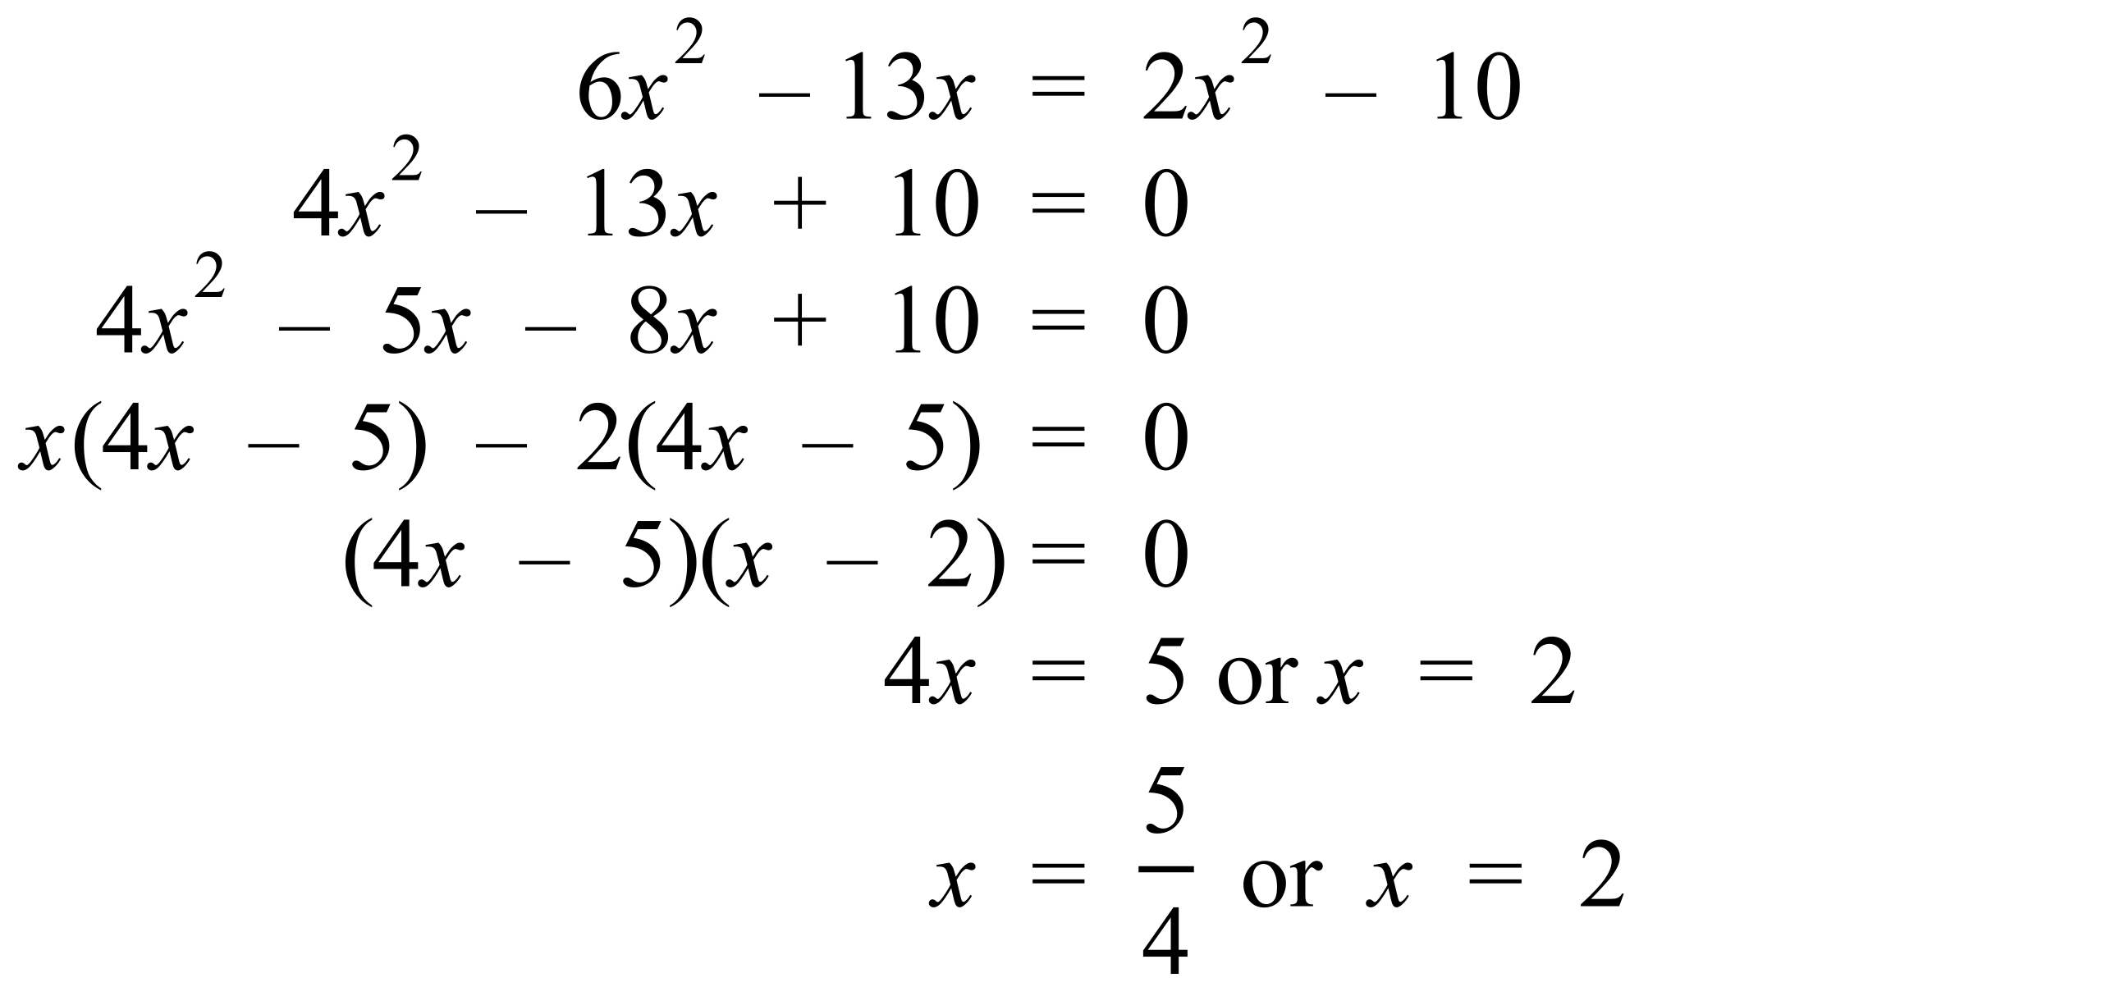 | B
 | 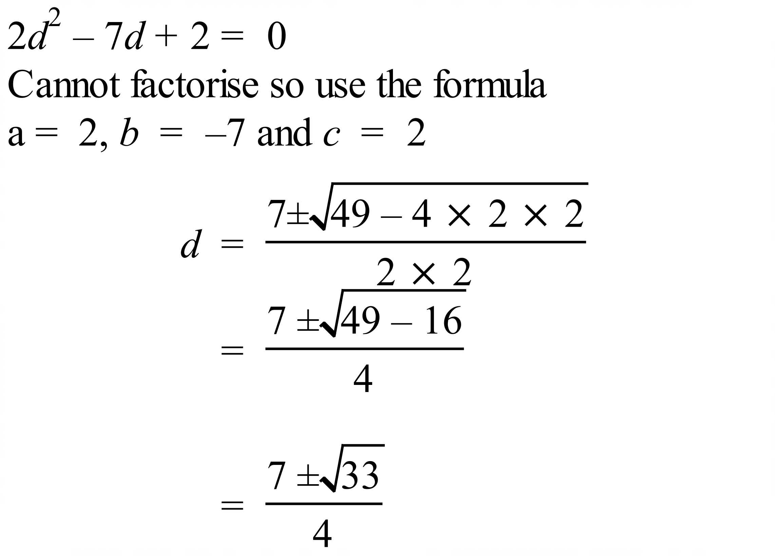 | D
 | 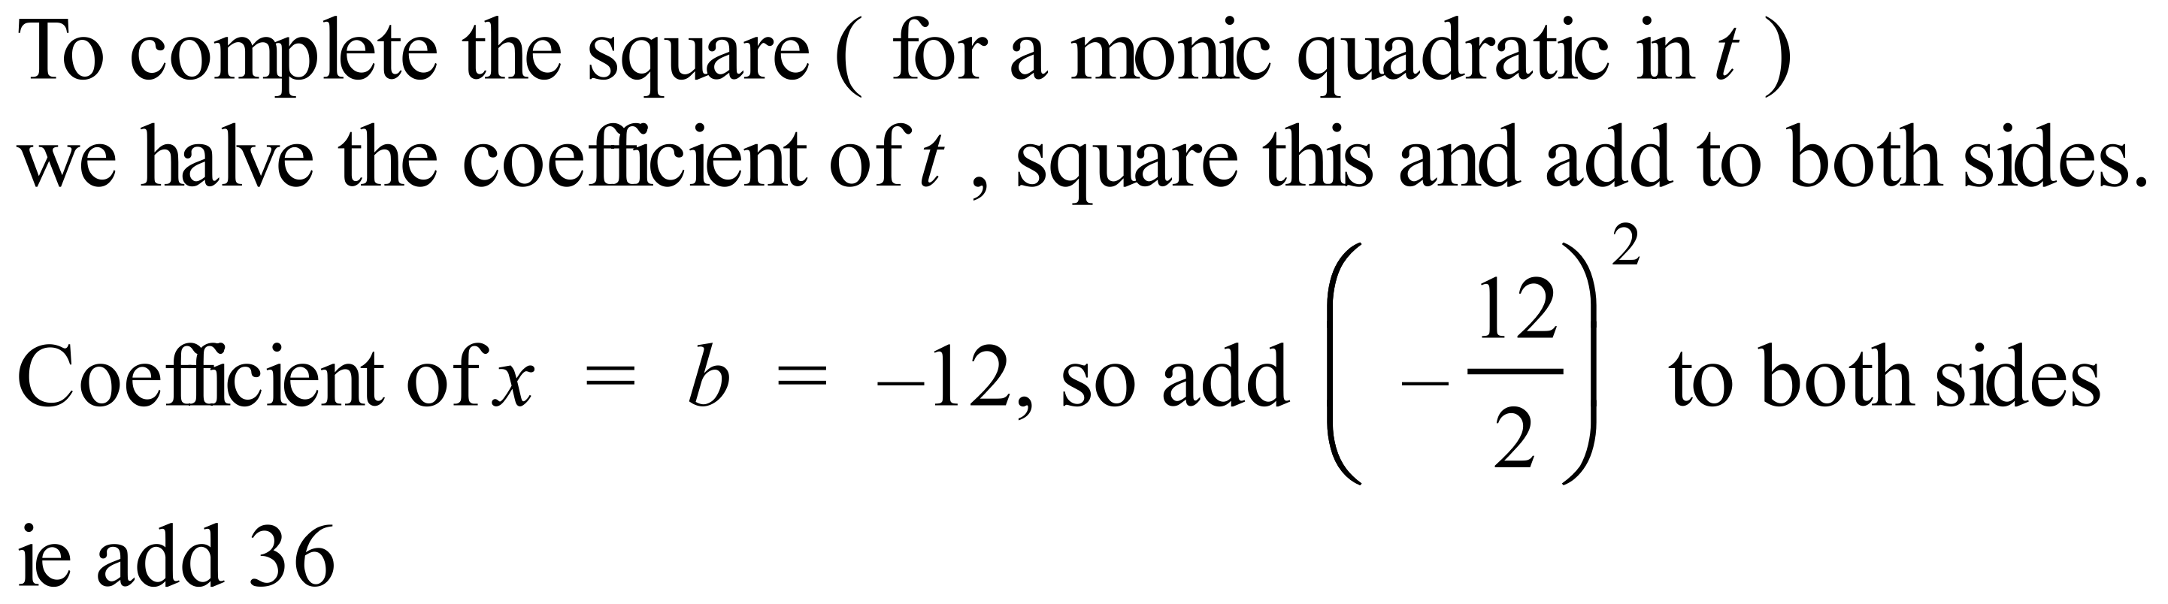 | B
 | 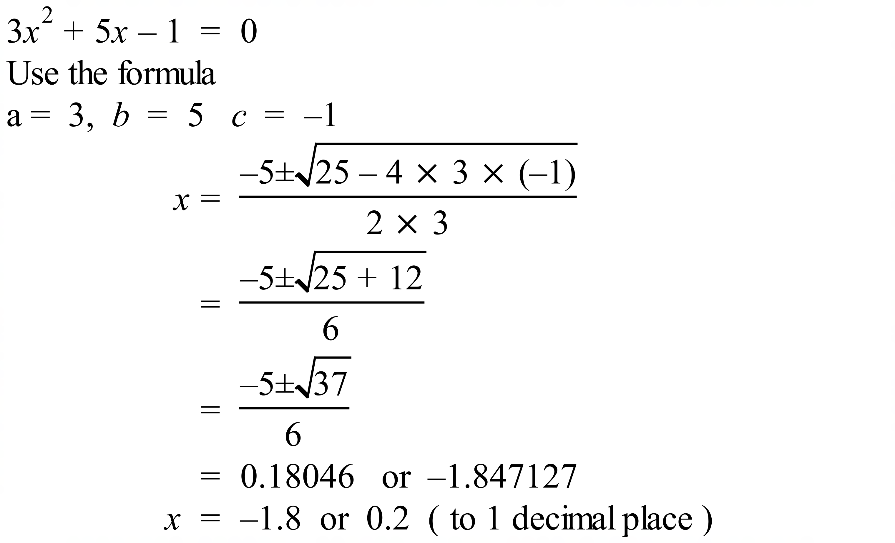 | A
 | 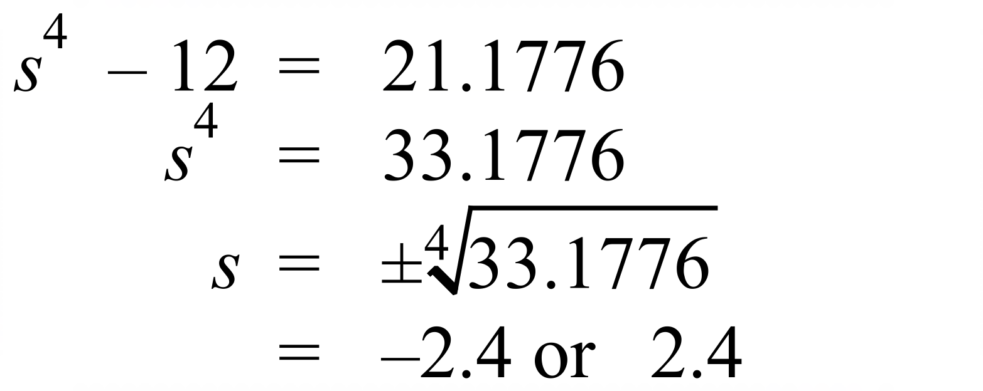 | A
 | 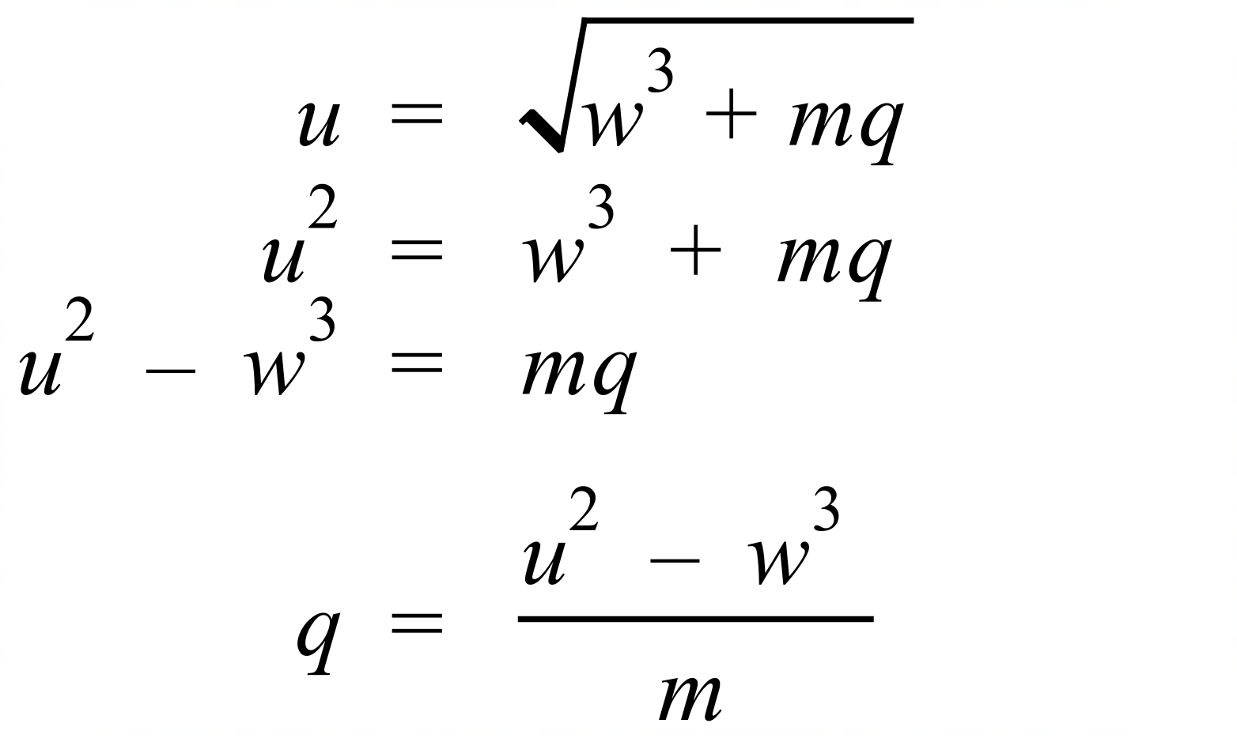 | B

School Name
Mathematics 2017
Multiple Choice Answer Sheet
Non Linear Equations
Name _____________________________________________
Completely fill the response oval representing the most correct answer.
1. A B C D
2. A B C D
3. A B C D
4. A B C D
5. A B C D
6. A B C D
7. A B C D
8. A B C D
9. A B C D
10. A B C D
11. A B C D
12. A B C D
13. A B C D
14. A B C D
15. A B C D
16. A B C D

School Name
Mathematics Test 2017
Year 10A | Non Linear Equations | Calculator Allowed  Longer Answer  Section
ANSWERS
Question | Working and Answer | Marks
1. | (a) 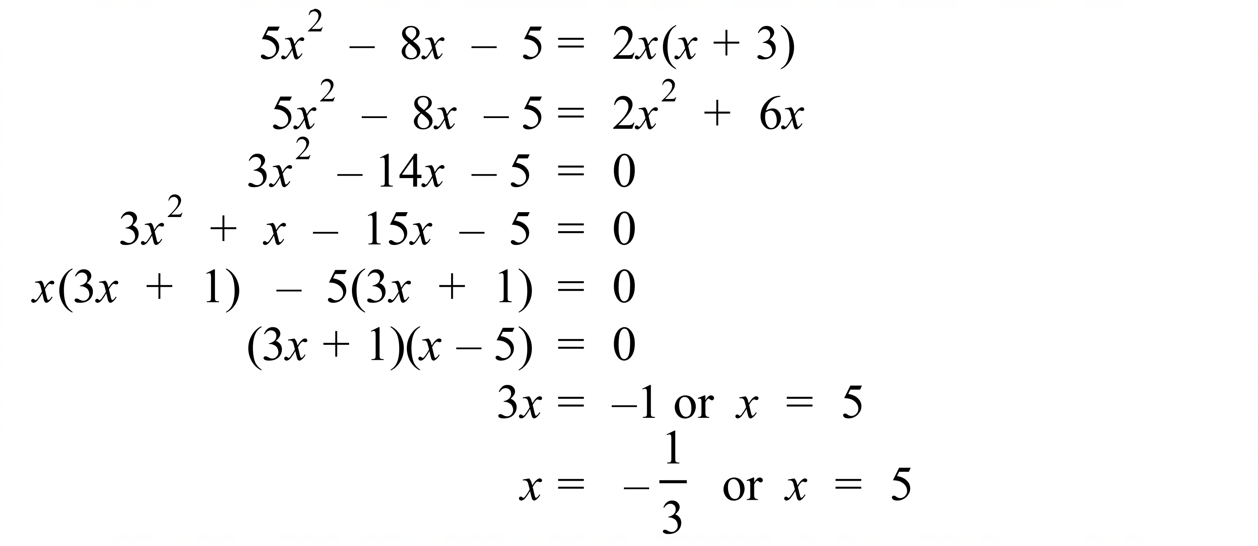 | 3 marks for complete solution  2 marks for solution with a minor error  1 mark for attempt that includes expanding and simplifying
 | (b) 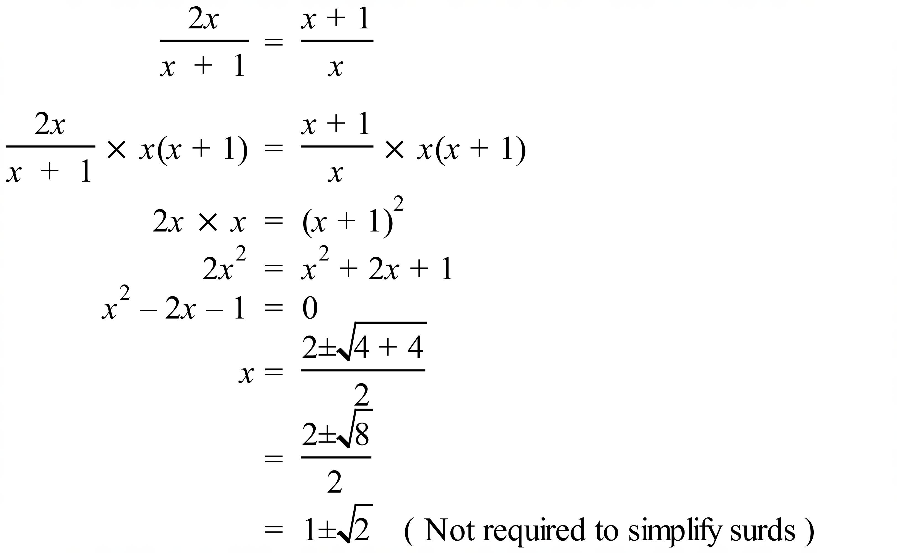 | 3 marks for complete solution  2 marks for solution with a minor error  1 mark for attempt that includes expanding and simplifying
 | (c) i) Since they differ by 12.5 and n is the smaller, the larger number is n + 12.5  ii) The equation is 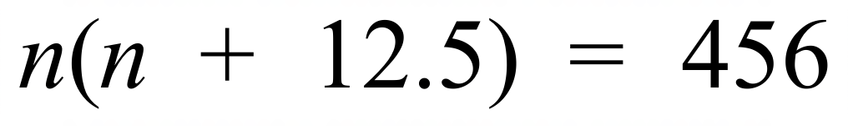  iii)  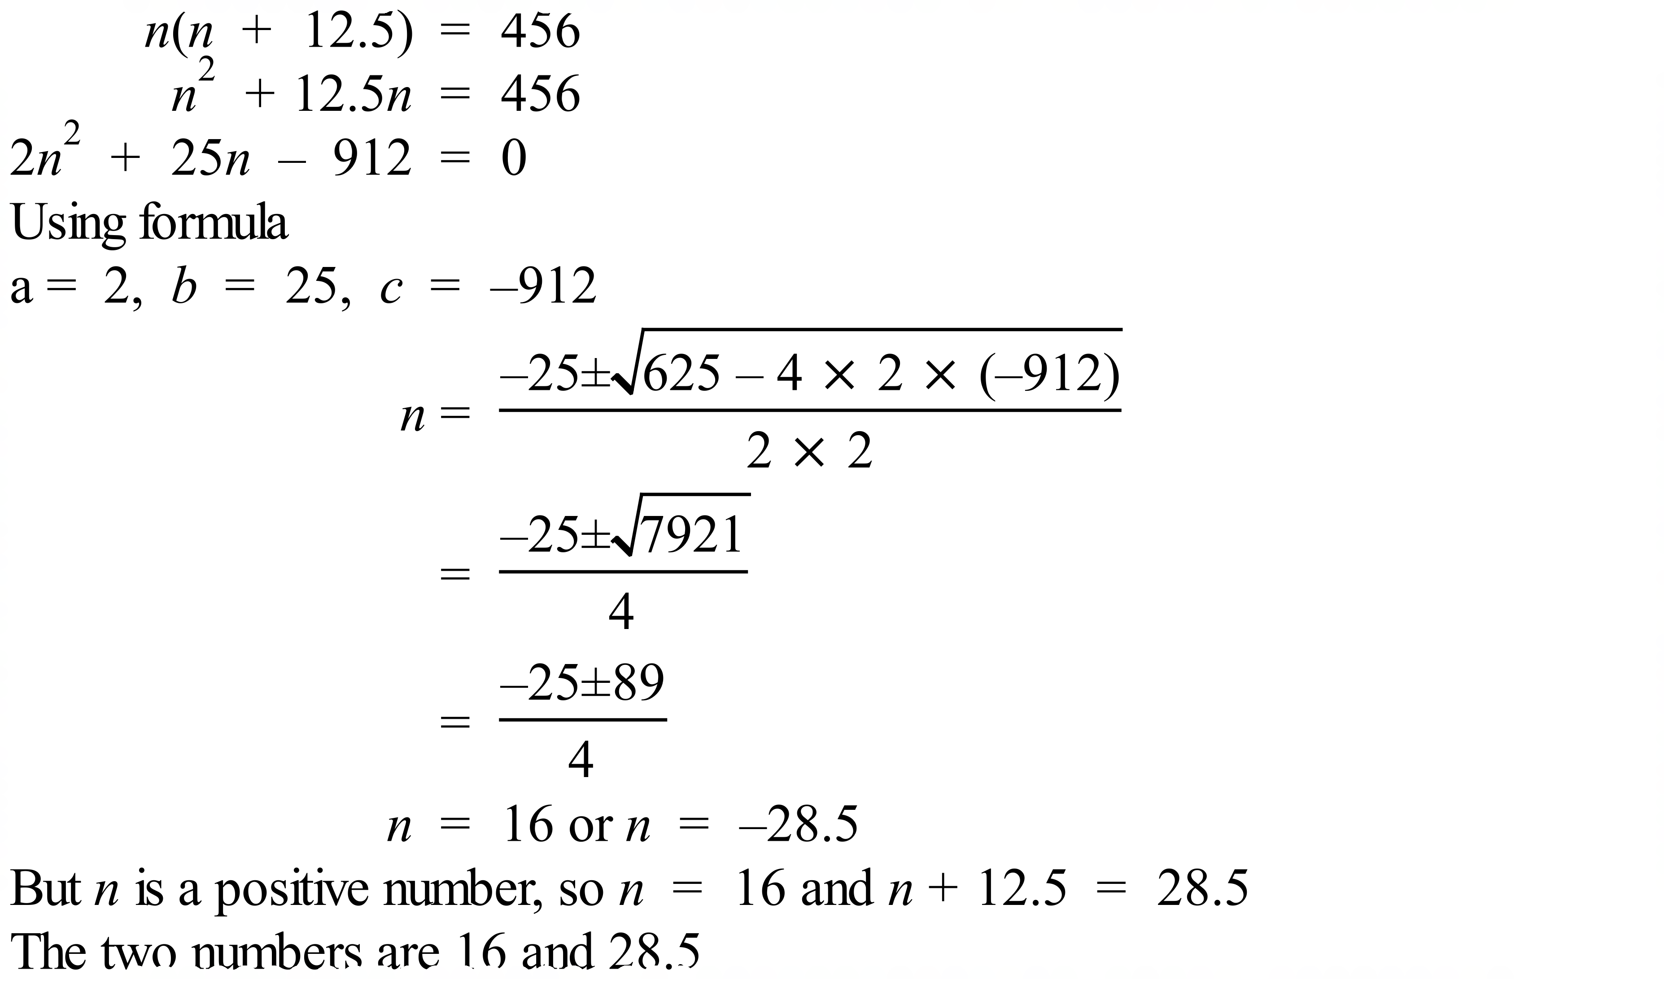  Can also be done by factorising, completing the square or guess and check. | 1 mark  1 mark  3 marks for correctly solving the equation and giving the answer  2 marks for a mainly correct solution with a minor error  1 mark for an incorrect attempt at solving the equation that shows some correct working
2. | 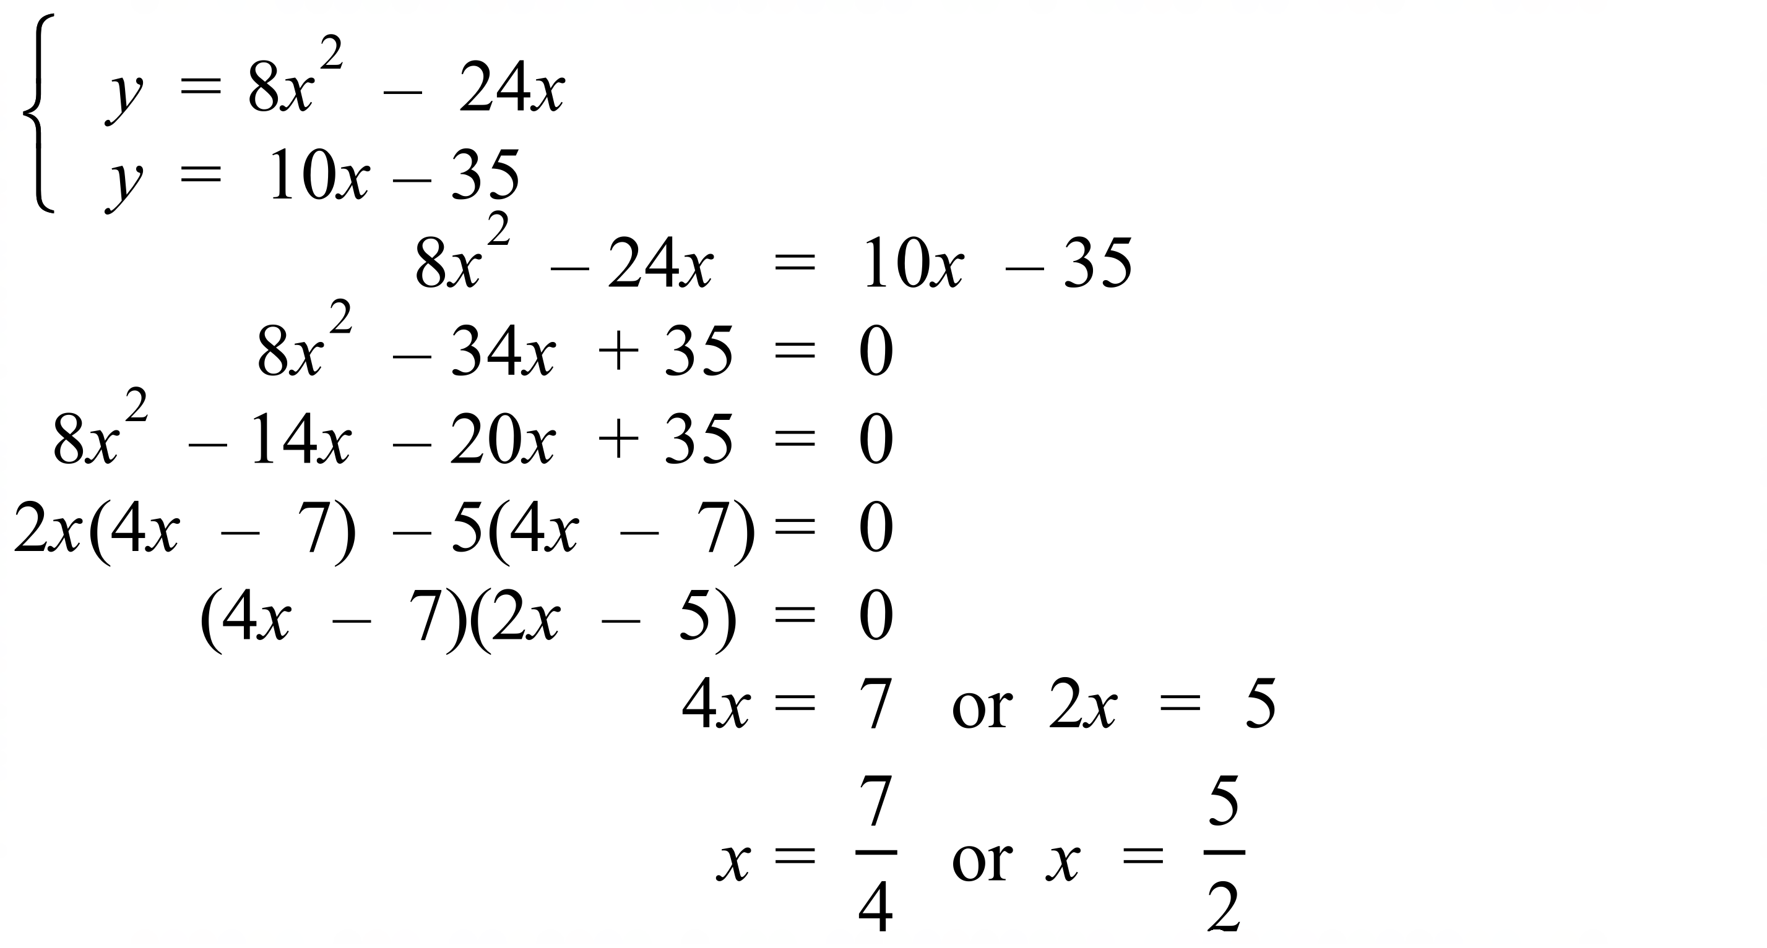 | 3 marks complete solution which includes substitution to create quadratic equation, solution of quadratic and writing of answers.  2 marks partially correct solution, for example not substituting correctly or not solving the quadratic correctly and writing two answers.  Allocate 1 mark for working that includes some correct reasoning and calculations.

